**JAVA SWING BASED – Crop disease severity- SQL**

**CONNECTIVITY USING JDBC**

*A*

*Report*

*Submitted in partial fulfillment of the Requirements for the award of the Degree of*

**BACHELOR OF ENGINEERING IN**

**INFORMATION TECHNOLOGY**

**By**

### T.Devi srujana<1602-20-737-011> Under the guidance of Ms B. Leelavathy



**Department of Information Technology Vasavi College of Engineering (Autonomous)**

### (Affiliated to Osmania University) Ibrahimbagh, Hyderabad-31

**2021-2022**

BONAFIDE CERTIFICATE

This is to certify that this project report titled

***‘Crop disease severity’***

is a project work of **T.Devi srujana** bearing roll no. 1602-20-737-011 who carried out this

project under my supervision in the IV semester for the academic year 2021- 2022

Signature Signature

External Examiner Internal Examiner

## Abstract:‐

Disease severity tracker which is used for tracking the severity of the diseases. In the present situation it is very difficult for the farmers to find out how sever the disease is, to find they have to visit the persons who know about plants very well, where farmers have to spend more money on it.so This automated tracker provides a convenient way to track diseases severity. Farmers can ask any issues regarding diseases and its severity.

## Requirement Analysis

##### List of Tables:

* Crop
* Diseases
* Factors
* Symptoms

##### List of Attributes with their Domain Types:

Crop table

* ID NUMBER(5)
* NAME VARCHAR2(20)

Diseases

* ID NUMBER(5)
* DISEASE VARCHAR2 (50)

Factors

* ID NUMBER(5)
* FACTOR VARCHAR(50)

Symptoms

* ID NUMBER(5)
* HIGH VARCHAR(80)
* LOW VARCHAR(80)
* MEDIUM VARCHAR(80)

# AIM AND PRIORITY OF THE PROJECT

To create a **Java GUI-based** desktop application that connects students looking for internships with project managers looking for interns. It takes values like student name, username, DOB, College name, etc through forms which are then updated in the database using JDBC connectivity.

# ARCHITECTURE AND TECHNOLOGY

### Software used:

Java Eclipse, Oracle 11g Database, Java SE version 18, SQL*Plus.

### Java SWING:

**Java SWING** is a GUI widget toolkit for Java. It is part of Oracle's Java Foundation Classes (JFC)

- an API for providing a graphical user interface (GUI) for Java programs.

Swing was developed to provide a more sophisticated set of GUI components than the earlier AWT. Swing provides a look and feel that emulates the look and feel of several platforms, and also supports a pluggable look and feel that allows applications to have a look and feel unrelated to the underlying platform. It has more powerful and flexible components than AWT. In addition to familiar components such as buttons, check boxes and labels, Swing provides several advanced components such as tabbed panel, scroll panes, trees, tables, and lists.

### SQL:

Structure Query Language(SQL) is a database query language used for storing and managing data in **Relational** DBMS. SQL was the first commercial language introduced for E.F Codd's Relational model of database. Today almost all RDBMS (MySql, Oracle, Infomix, Sybase, MS Access) use **SQL** as the standard database query language. SQL is used to perform all types of data operations in RDBMS.

**Entity Relationship Diagram**



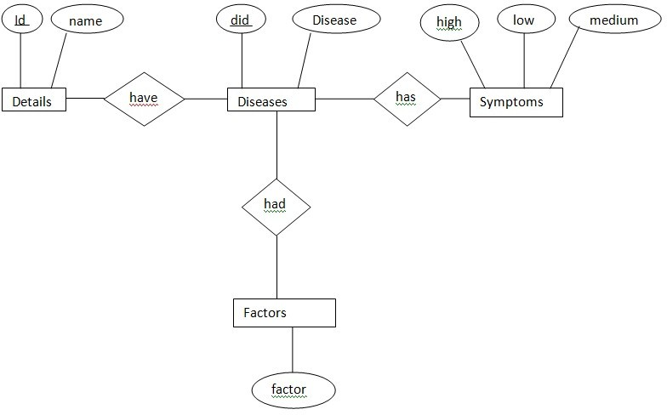

# DATABASE DESIGN

### Mapping Cardinality and Participation Constraints

Every user registered as a student has to have one (only one) student profile mandatorily in order to apply for internships. Therefore, this is a total participation and one-to-one relationship.

Similarly, every user registered as a project manager has to have one (only one) manager profile mandatorily in order to be able to post the internship openings. Therefore, this is a total participation and one-to-one relationship.

A student can apply to any number of different internships he/she wants and at the same time one internship can be applied to by many students, therefore, this is a many-to-many (or N-N) relationship.

Also, every student applies to at least one internship, because that is the reason he/she registered in the first place. Therefore, it is a total participation here from the students’ side.

Similarly, a project manager can post many internship openings, therefore, this is a one-to-many (or 1-N) relationship.

Also, every manager posts at least one internship, because that is the purpose of this application, therefore, it is a total participation from the project managers’ side.

### DDL Operations:-

1. Create table crop(

id number(5) primary key, name varchar2(20));

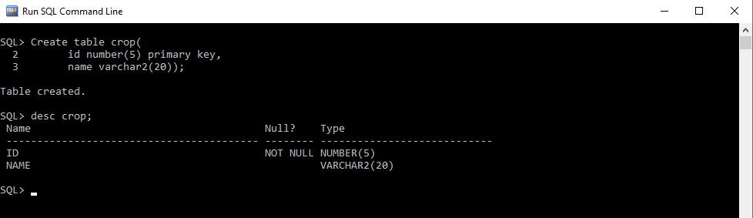

1. Create table diseases( id number(5) , disease varchar2(20),

Foreign key(id) references crop);

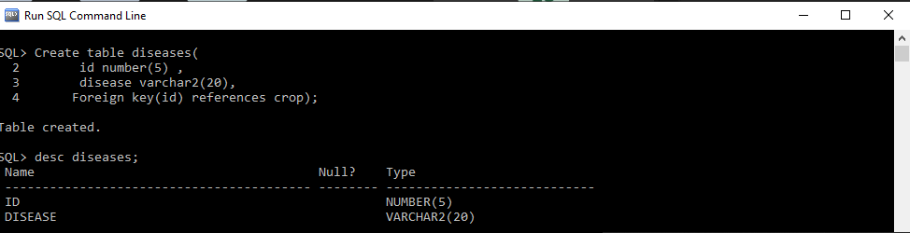

1. Create table factors( id number(5),

factor varchar2(50),

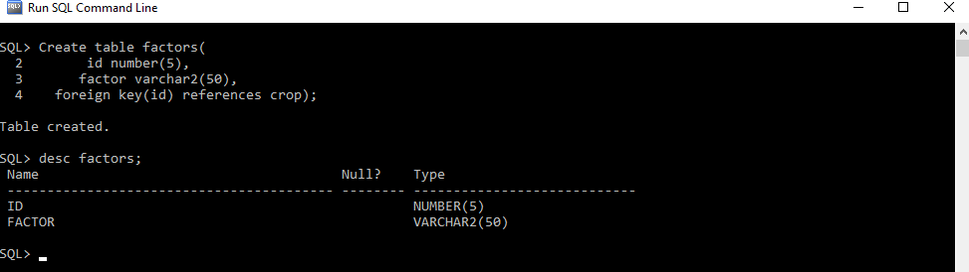foreign key(id) references crop);

1. create table symptoms( id number(5),

high varchar2(80), low varchar2(80), medium varchar2(80),

foreign key(id) references crop);

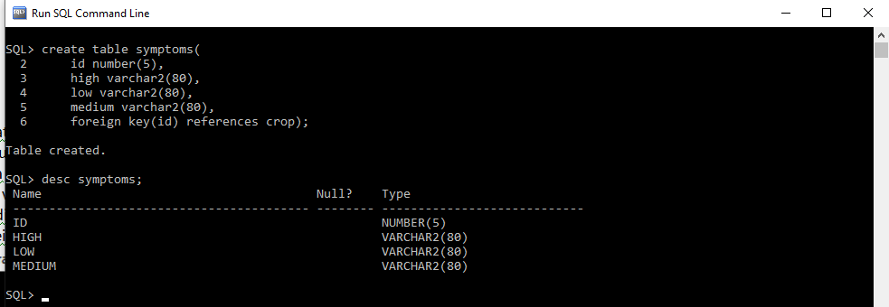

**DML COMMANDS:‐**

1. Inserting values into crop table

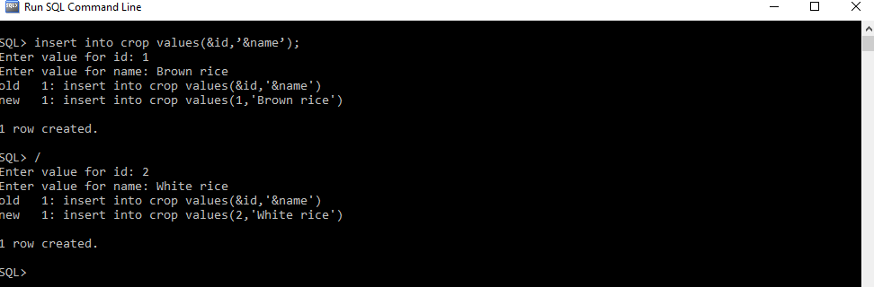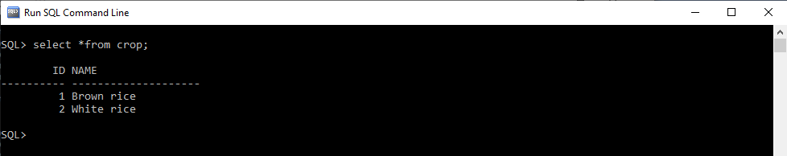Syntax:‐ insert into crop values(&id,’&name’);

1. Inserting values into diseases tables

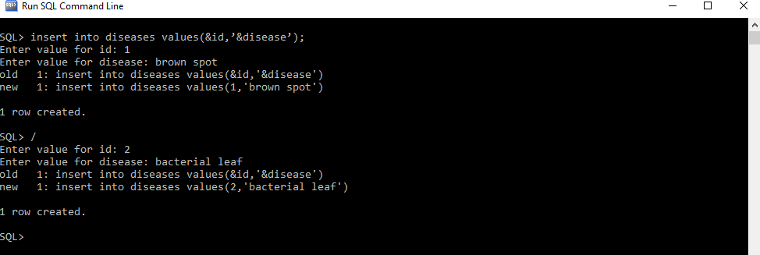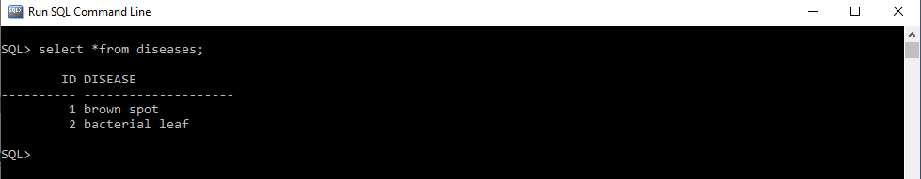Syntax :‐ insert into diseases values(&id,’&disease’,&id);

1. Inserting values into factors tables

Syntax :‐ insert into factors values(&id,’&factors’);

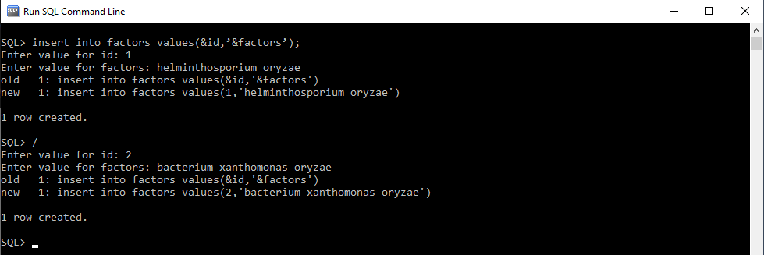

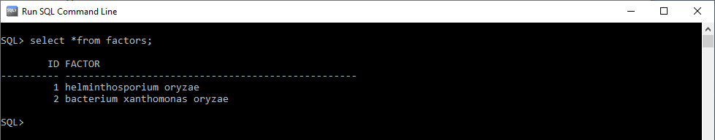

1. Inserting values into symptoms tables

Syntax :‐ insert into symptoms values(&id,’&high’,’&low’,’&medium’);

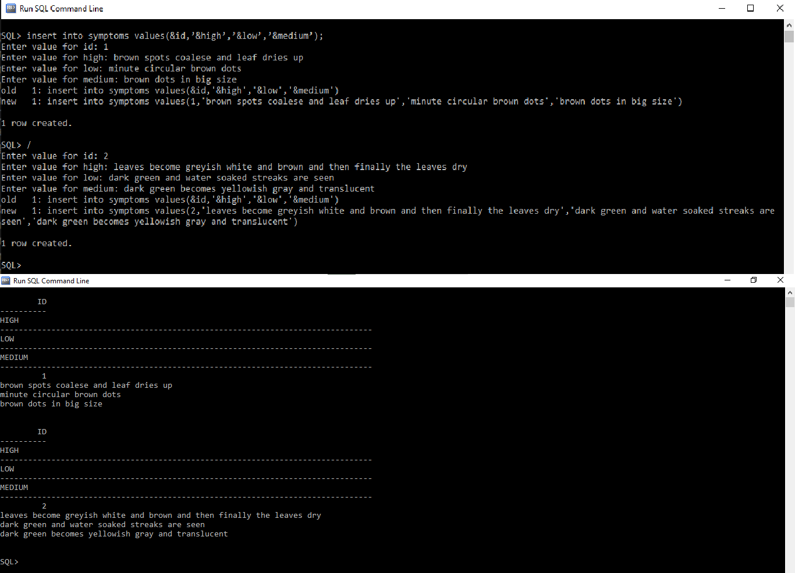

# IMPLEMENTATION

### JAVA-SQL Connectivity using JDBC:

**Java Database Connectivity (JDBC)** is an application programming interface (API) for the programming language Java, which defines how a client may access a database. It is a Java- based data access technology used for Java database connectivity. It is part of the Java Standard Edition platform, from Oracle Corporation. It provides methods to query and update data in a database and is oriented towards relational databases.

The connection to the database can be performed using Java programming (JDBC API) as:

Mainui.java

public class Mainui extends javax.swing.JFrame { public Mainui() {

initComponents();

}

private void initComponents() {

jLabel1 = new javax.swing.JLabel(); jButton1 = new javax.swing.JButton(); jButton2 = new javax.swing.JButton(); jLabel2 = new javax.swing.JLabel(); jLabel3 = new javax.swing.JLabel(); jLabel4 = new javax.swing.JLabel();

setDefaultCloseOperation(javax.swing.WindowConstants.EXIT_ON_CLOSE); getContentPane().setLayout(new org.netbeans.lib.awtextra.AbsoluteLayout());

jLabel1.setFont(new java.awt.Font("Segoe UI", 1, 36)); // NOI18N jLabel1.setForeground(new java.awt.Color(0, 255, 255)); jLabel1.setText("Crop Disease Severity");

getContentPane().add(jLabel1, new org.netbeans.lib.awtextra.AbsoluteConstraints(100, 60, 370, 56));

jButton1.setText("Edit Data");

jButton1.addActionListener(new java.awt.event.ActionListener() { public void actionPerformed(java.awt.event.ActionEvent evt) {

jButton1ActionPerformed(evt);

}

});

getContentPane().add(jButton1, new org.netbeans.lib.awtextra.AbsoluteConstraints(120, 170, 113, 57));

jButton2.setText("Check_severity"); jButton2.addActionListener(new java.awt.event.ActionListener() {

public void actionPerformed(java.awt.event.ActionEvent evt) {

jButton2ActionPerformed(evt);

}

});

getContentPane().add(jButton2, new org.netbeans.lib.awtextra.AbsoluteConstraints(310, 170, 120, 57));

jLabel2.setFont(new java.awt.Font("Segoe UI", 3, 18)); // NOI18N jLabel2.setForeground(new java.awt.Color(255, 255, 0)); jLabel2.setText("Admin‐Click on the button edit data to change data in table ");

getContentPane().add(jLabel2, new org.netbeans.lib.awtextra.AbsoluteConstraints(30, 280, ‐1, ‐1));

jLabel3.setFont(new java.awt.Font("Segoe UI", 3, 18)); // NOI18N jLabel3.setForeground(new java.awt.Color(255, 255, 0));

jLabel3.setText("User‐Click on the Check_severity to check the crop disease severity"); getContentPane().add(jLabel3, new org.netbeans.lib.awtextra.AbsoluteConstraints(10, 300, ‐1, ‐1));

jLabel4.setIcon(new javax.swing.ImageIcon(getClass().getResource("/download (6).jpg"))); // NOI18N jLabel4.setText("jLabel4");

getContentPane().add(jLabel4, new org.netbeans.lib.awtextra.AbsoluteConstraints(0, 0, 590, 420));

pack();

}

private void jButton1ActionPerformed(java.awt.event.ActionEvent evt) {//GEN‐ FIRST:event_jButton1ActionPerformed

Change_data c=new Change_data(); c.show();

}

private void jButton2ActionPerformed(java.awt.event.ActionEvent evt) {//GEN‐ FIRST:event_jButton2ActionPerformed

Check_severity cs=new Check_severity(); cs.show();

}

public static void main(String args[]) { try {

for (javax.swing.UIManager.LookAndFeelInfo info : javax.swing.UIManager.getInstalledLookAndFeels()) { if ("Nimbus".equals(info.getName())) {

javax.swing.UIManager.setLookAndFeel(info.getClassName()); break;

}

}

} catch (ClassNotFoundException ex) { java.util.logging.Logger.getLogger(Mainui.class.getName()).log(java.util.logging.Level.SEVERE, null, ex);

} catch (InstantiationException ex) { java.util.logging.Logger.getLogger(Mainui.class.getName()).log(java.util.logging.Level.SEVERE, null, ex);

} catch (IllegalAccessException ex) { java.util.logging.Logger.getLogger(Mainui.class.getName()).log(java.util.logging.Level.SEVERE, null, ex);

} catch (javax.swing.UnsupportedLookAndFeelException ex) { java.util.logging.Logger.getLogger(Mainui.class.getName()).log(java.util.logging.Level.SEVERE, null, ex);

}

java.awt.EventQueue.invokeLater(new Runnable() { public void run() {

new Mainui().setVisible(true);

}

});

}

private javax.swing.JButton jButton1; private javax.swing.JButton jButton2; private javax.swing.JLabel jLabel1; private javax.swing.JLabel jLabel2; private javax.swing.JLabel jLabel3; private javax.swing.JLabel jLabel4;

}

HOME‐PAGE:‐

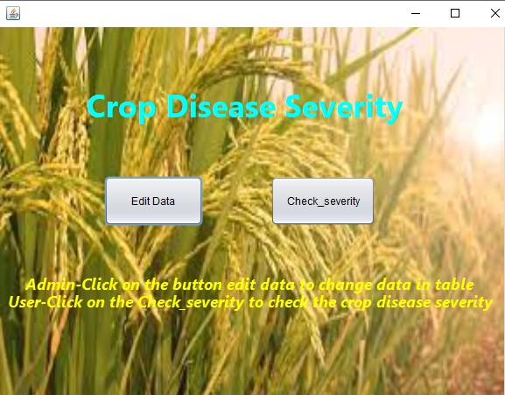

#### Change_data.java

public class Change_data extends javax.swing.JFrame { public Change_data() {

initComponents();

}

private void initComponents() { jButton4 = new javax.swing.JButton(); jButton5 = new javax.swing.JButton(); jButton6 = new javax.swing.JButton(); jButton7 = new javax.swing.JButton(); jButton1 = new javax.swing.JButton(); jLabel1 = new javax.swing.JLabel();

jMenuBar1 = new javax.swing.JMenuBar();

setDefaultCloseOperation(javax.swing.WindowConstants.EXIT_ON_CLOSE); getContentPane().setLayout(new org.netbeans.lib.awtextra.AbsoluteLayout());

jButton4.setText("Crop");

jButton4.addActionListener(new java.awt.event.ActionListener() { public void actionPerformed(java.awt.event.ActionEvent evt) {

jButton4ActionPerformed(evt);

}

});

getContentPane().add(jButton4, new org.netbeans.lib.awtextra.AbsoluteConstraints(70, 63, 144, 72));

jButton5.setText("Diseases");

jButton5.addActionListener(new java.awt.event.ActionListener() { public void actionPerformed(java.awt.event.ActionEvent evt) {

jButton5ActionPerformed(evt);

}

});

getContentPane().add(jButton5, new org.netbeans.lib.awtextra.AbsoluteConstraints(331, 64, 128, 71));

jButton6.setText("Factors");

jButton6.addActionListener(new java.awt.event.ActionListener() { public void actionPerformed(java.awt.event.ActionEvent evt) {

jButton6ActionPerformed(evt);

}

});

getContentPane().add(jButton6, new org.netbeans.lib.awtextra.AbsoluteConstraints(70, 255, 144, 71));

jButton7.setText("Symptoms");

jButton7.addActionListener(new java.awt.event.ActionListener() { public void actionPerformed(java.awt.event.ActionEvent evt) {

jButton7ActionPerformed(evt);

}

});

getContentPane().add(jButton7, new org.netbeans.lib.awtextra.AbsoluteConstraints(331, 255, 128, 71));

jButton1.setText("Back");

jButton1.addActionListener(new java.awt.event.ActionListener() { public void actionPerformed(java.awt.event.ActionEvent evt) {

jButton1ActionPerformed(evt);

}

});

getContentPane().add(jButton1, new org.netbeans.lib.awtextra.AbsoluteConstraints(0, 420, ‐1, ‐1));

jLabel1.setIcon(new javax.swing.ImageIcon(getClass().getResource("/download (6).jpg"))); // NOI18N jLabel1.setText("jLabel1");

getContentPane().add(jLabel1, new org.netbeans.lib.awtextra.AbsoluteConstraints(0, 0, 580, 440)); setJMenuBar(jMenuBar1);

pack();

}

private void jButton4ActionPerformed(java.awt.event.ActionEvent evt) {//GEN‐FIRST:event_jButton4ActionPerformed Detail e=new Detail();

e.show();

}

private void jButton5ActionPerformed(java.awt.event.ActionEvent evt) {//GEN‐FIRST:event_jButton5ActionPerformed Diseases d=new Diseases();

d.show();

}

private void jButton6ActionPerformed(java.awt.event.ActionEvent evt) {//GEN‐FIRST:event_jButton6ActionPerformed Factors f=new Factors();

f.show();

}

private void jButton7ActionPerformed(java.awt.event.ActionEvent evt) {//GEN‐FIRST:event_jButton7ActionPerformed

Symptoms s= new Symptoms(); s.show();

}

private void jButton1ActionPerformed(java.awt.event.ActionEvent evt) {//GEN‐FIRST:event_jButton1ActionPerformed

dispose();

}

public static void main(String args[]) {

try {

for (javax.swing.UIManager.LookAndFeelInfo info : javax.swing.UIManager.getInstalledLookAndFeels()) { if ("Nimbus".equals(info.getName())) {

javax.swing.UIManager.setLookAndFeel(info.getClassName()); break;

}

}

} catch (ClassNotFoundException ex) { java.util.logging.Logger.getLogger(Change_data.class.getName()).log(java.util.logging.Level.SEVERE, null, ex);

} catch (InstantiationException ex) { java.util.logging.Logger.getLogger(Change_data.class.getName()).log(java.util.logging.Level.SEVERE, null, ex);

} catch (IllegalAccessException ex) { java.util.logging.Logger.getLogger(Change_data.class.getName()).log(java.util.logging.Level.SEVERE, null, ex);

} catch (javax.swing.UnsupportedLookAndFeelException ex) { java.util.logging.Logger.getLogger(Change_data.class.getName()).log(java.util.logging.Level.SEVERE, null, ex);

}

java.awt.EventQueue.invokeLater(new Runnable() { public void run() {

new Change_data().setVisible(true);

}

});

}

private javax.swing.JButton jButton1; private javax.swing.JButton jButton4; private javax.swing.JButton jButton5; private javax.swing.JButton jButton6; private javax.swing.JButton jButton7; private javax.swing.JLabel jLabel1;

private javax.swing.JMenuBar jMenuBar1;

}

Edit Data:‐

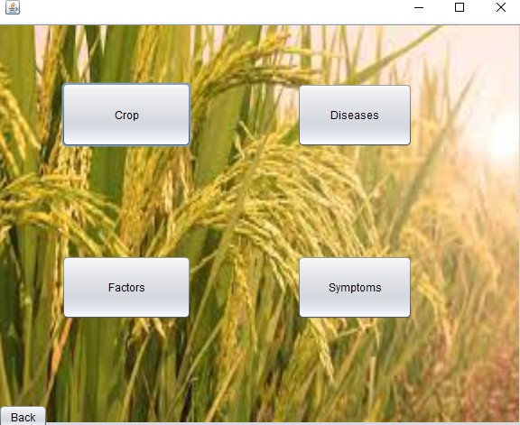

#### Details.java

import java.sql.Connection; import java.sql.DriverManager; import java.sql.ResultSet; import java.sql.Statement; import javax.swing.JFrame; import javax.swing.JOptionPane;

import javax.swing.table.DefaultTableModel; public class Detail extends javax.swing.JFrame {

public Detail() { initComponents();

}

private void initComponents() {

jTextField3 = new javax.swing.JTextField(); jLabel1 = new javax.swing.JLabel(); jLabel2 = new javax.swing.JLabel(); jTextField1 = new javax.swing.JTextField(); jTextField2 = new javax.swing.JTextField(); jLabel3 = new javax.swing.JLabel(); jButton1 = new javax.swing.JButton(); jButton2 = new javax.swing.JButton(); jButton3 = new javax.swing.JButton(); jButton4 = new javax.swing.JButton(); jButton5 = new javax.swing.JButton(); jLabel4 = new javax.swing.JLabel();

jScrollPane1 = new javax.swing.JScrollPane(); jTable1 = new javax.swing.JTable();

jLabel5 = new javax.swing.JLabel(); jTextField3.setText("jTextField3");

setDefaultCloseOperation(javax.swing.WindowConstants.EXIT_ON_CLOSE); getContentPane().setLayout(new org.netbeans.lib.awtextra.AbsoluteLayout());

jLabel1.setText("Crop_ID:");

getContentPane().add(jLabel1, new org.netbeans.lib.awtextra.AbsoluteConstraints(6, 87, 80, ‐1));

jLabel2.setText("Crop_Name:");

getContentPane().add(jLabel2, new org.netbeans.lib.awtextra.AbsoluteConstraints(6, 163, ‐1, ‐1));

jTextField1.addActionListener(new java.awt.event.ActionListener() { public void actionPerformed(java.awt.event.ActionEvent evt) {

jTextField1ActionPerformed(evt);

}

});

getContentPane().add(jTextField1, new org.netbeans.lib.awtextra.AbsoluteConstraints(92, 67, 360, 57));

jTextField2.addActionListener(new java.awt.event.ActionListener() { public void actionPerformed(java.awt.event.ActionEvent evt) {

jTextField2ActionPerformed(evt);

}

});

getContentPane().add(jTextField2, new org.netbeans.lib.awtextra.AbsoluteConstraints(92, 142, 360, 58));

jLabel3.setFont(new java.awt.Font("Segoe UI", 0, 24)); jLabel3.setText("Details ");

getContentPane().add(jLabel3, new org.netbeans.lib.awtextra.AbsoluteConstraints(0, 0, 128, ‐1));

jButton1.setText("Submit");

jButton1.addActionListener(new java.awt.event.ActionListener() { public void actionPerformed(java.awt.event.ActionEvent evt) {

jButton1ActionPerformed(evt);

}

});

getContentPane().add(jButton1, new org.netbeans.lib.awtextra.AbsoluteConstraints(507, 84, ‐1, ‐1));

jButton2.setText("Modify");

jButton2.addActionListener(new java.awt.event.ActionListener() { public void actionPerformed(java.awt.event.ActionEvent evt) {

jButton2ActionPerformed(evt);

}

});

getContentPane().add(jButton2, new org.netbeans.lib.awtextra.AbsoluteConstraints(647, 84, ‐1, ‐1));

jButton3.setText("Delete");

jButton3.addActionListener(new java.awt.event.ActionListener() { public void actionPerformed(java.awt.event.ActionEvent evt) {

jButton3ActionPerformed(evt);

}

});

getContentPane().add(jButton3, new org.netbeans.lib.awtextra.AbsoluteConstraints(647, 160, ‐1, ‐1));

jButton4.setText("Back");

jButton4.addActionListener(new java.awt.event.ActionListener() { public void actionPerformed(java.awt.event.ActionEvent evt) {

jButton4ActionPerformed(evt);

}

});

getContentPane().add(jButton4, new org.netbeans.lib.awtextra.AbsoluteConstraints(0, 470, ‐1, ‐1));

jButton5.setText("View");

jButton5.addActionListener(new java.awt.event.ActionListener() {

public void actionPerformed(java.awt.event.ActionEvent evt) { jButton5ActionPerformed(evt);

}

});

getContentPane().add(jButton5, new org.netbeans.lib.awtextra.AbsoluteConstraints(507, 160, ‐1, ‐1));

jLabel4.setFont(new java.awt.Font("Segoe UI", 0, 18)); jLabel4.setText("Crop Table View");

getContentPane().add(jLabel4, new org.netbeans.lib.awtextra.AbsoluteConstraints(6, 226, ‐1, ‐1));

jTable1.setModel(new javax.swing.table.DefaultTableModel( new Object [][] {

{null, null},

{null, null},

{null, null},

{null, null},

{null, null},

{null, null},

{null, null},

{null, null},

{null, null},

{null, null}

},

new String [] {

"Crop_ID", "Crop_Name"

}

) {

Class[] types = new Class [] { java.lang.Integer.class, java.lang.String.class

};

public Class getColumnClass(int columnIndex) { return types [columnIndex];

}

});

jTable1.addMouseListener(new java.awt.event.MouseAdapter() { public void mouseClicked(java.awt.event.MouseEvent evt) {

jTable1MouseClicked(evt);

}

});

jScrollPane1.setViewportView(jTable1);

getContentPane().add(jScrollPane1, new org.netbeans.lib.awtextra.AbsoluteConstraints(82, 285, 479, 179));

jLabel5.setIcon(new javax.swing.ImageIcon(getClass().getResource("/images (1).jpg"))); jLabel5.setText("jLabel5");

getContentPane().add(jLabel5, new org.netbeans.lib.awtextra.AbsoluteConstraints(0, 0, 740, 490));

pack();

}

private void jTextField1ActionPerformed(java.awt.event.ActionEvent evt) {

}

private void jButton1ActionPerformed(java.awt.event.ActionEvent evt) { try

{

DriverManager.registerDriver(new oracle.jdbc.driver.OracleDriver());

Connection con = (Connection) DriverManager.getConnection("jdbc:oracle:thin:@localhost:1521:XE"

,"srujana","vasavi");

Statement statement = con.createStatement();

String query = "INSERT INTO CROP VALUES(" + "'"+jTextField1.getText() + "',"+"'"+ jTextField2.getText()+"'" +")"; ResultSet rs = statement.executeQuery(query);

JOptionPane.showMessageDialog(new JFrame(), "Inserted Successfully", "INFORMATION", JOptionPane.INFORMATION_MESSAGE);

rs.close(); statement.close(); con.close();

}

catch(Exception e)

{

JOptionPane.showMessageDialog(new JFrame(),e, "ERROR", JOptionPane.ERROR_MESSAGE);

}

}

private void jButton4ActionPerformed(java.awt.event.ActionEvent evt) {

dispose();

}

private void jButton2ActionPerformed(java.awt.event.ActionEvent evt) {

try

{

if(jTable1.getRowCount()==0)

{

JOptionPane.showMessageDialog(this, "Please View the table to Update", "Notice",

JOptionPane.INFORMATION_MESSAGE);

}

else

{

int r = jTable1.getSelectedRow(); if(r<0)

{

JOptionPane.showMessageDialog(this, "Please select single Row from View table to Update", "Notice", JOptionPane.INFORMATION_MESSAGE);

}

else

{

DriverManager.registerDriver(new oracle.jdbc.driver.OracleDriver());

Connection con = DriverManager.getConnection("jdbc:oracle:thin:@localhost:1521:XE" ,"srujana","vasavi"); Statement statement = con.createStatement();

ResultSet rs = statement.executeQuery(query);

JOptionPane.showMessageDialog(new JFrame(), "Updated Successfully", "INFORMATION", JOptionPane.INFORMATION_MESSAGE);

rs.close(); statement.close(); con.close();

}

}

}

catch(Exception e)

{

JOptionPane.showMessageDialog(new JFrame(),e, "INFORMATION", JOptionPane.INFORMATION_MESSAGE);

}

}

private void jButton3ActionPerformed(java.awt.event.ActionEvent evt) { try

{

if(jTable1.getRowCount()==0)

{

JOptionPane.showMessageDialog(this, "Please View the table to Delete", "Notice", JOptionPane.INFORMATION_MESSAGE);

}

else

{

int r = jTable1.getSelectedRow();

if(r<0)

{

JOptionPane.showMessageDialog(this, "Please select single Row from view table to Delete", "Notice", JOptionPane.INFORMATION_MESSAGE);

}

else

{

DriverManager.registerDriver(new oracle.jdbc.driver.OracleDriver());

Connection con = DriverManager.getConnection("jdbc:oracle:thin:@localhost:1521:XE" ,"srujana","vasavi"); Statement statement = con.createStatement()

String query = "DELETE from crop where ID = '" + jTextField1.getText() + "'"; ResultSet rs = statement.executeQuery(query);

JOptionPane.showMessageDialog(new JFrame(), "Deleted Successfully", "INFORMATION", JOptionPane.INFORMATION_MESSAGE);

rs.close(); statement.close(); con.close();

}

}

}

catch(Exception e)

{

JOptionPane.showMessageDialog(new JFrame(),e, "INFORMATION", JOptionPane.INFORMATION_MESSAGE);

}

}

private void jButton5ActionPerformed(java.awt.event.ActionEvent evt) { try

{

DriverManager.registerDriver(new oracle.jdbc.driver.OracleDriver());

Connection con = DriverManager.getConnection("jdbc:oracle:thin:@localhost:1521:XE" ,"srujana","vasavi"); Statement statement = con.createStatement();

String query = "SELECT * FROM crop"; ResultSet rs = statement.executeQuery(query);

DefaultTableModel model = (DefaultTableModel)jTable1.getModel();

model.setRowCount(0); while(rs.next())

{

model.addRow(new Object[]{ rs.getString("ID"), rs.getString("name") });

}

rs.close(); statement.close(); con.close();

}

catch(Exception e)

{

JOptionPane.showMessageDialog(new JFrame(),e, "INFORMATION", JOptionPane.INFORMATION_MESSAGE);

}

}

private void jTable1MouseClicked(java.awt.event.MouseEvent evt) {

DefaultTableModel model = (DefaultTableModel)jTable1.getModel(); int rowindex = jTable1.getSelectedRow(); jTextField1.setText(model.getValueAt(rowindex,0).toString()); jTextField2.setText(model.getValueAt(rowindex,1).toString());

}

public static void main(String args[]) {

try {

for (javax.swing.UIManager.LookAndFeelInfo info : javax.swing.UIManager.getInstalledLookAndFeels()) { if ("Nimbus".equals(info.getName())) {

javax.swing.UIManager.setLookAndFeel(info.getClassName()); break;

}

}

} catch (ClassNotFoundException ex) { java.util.logging.Logger.getLogger(Detail.class.getName()).log(java.util.logging.Level.SEVERE, null, ex);

} catch (InstantiationException ex) { java.util.logging.Logger.getLogger(Detail.class.getName()).log(java.util.logging.Level.SEVERE, null, ex);

} catch (IllegalAccessException ex) { java.util.logging.Logger.getLogger(Detail.class.getName()).log(java.util.logging.Level.SEVERE, null, ex);

} catch (javax.swing.UnsupportedLookAndFeelException ex) { java.util.logging.Logger.getLogger(Detail.class.getName()).log(java.util.logging.Level.SEVERE, null, ex);

}

java.awt.EventQueue.invokeLater(new Runnable() { public void run() {

new Detail().setVisible(true);

}

});

}

// Variables declaration ‐ do not modify//GEN‐BEGIN:variables private javax.swing.JButton jButton1;

private javax.swing.JButton jButton2; private javax.swing.JButton jButton3; private javax.swing.JButton jButton4; private javax.swing.JButton jButton5; private javax.swing.JLabel jLabel1; private javax.swing.JLabel jLabel2; private javax.swing.JLabel jLabel3; private javax.swing.JLabel jLabel4; private javax.swing.JLabel jLabel5;

private javax.swing.JScrollPane jScrollPane1; private javax.swing.JTable jTable1;

private javax.swing.JTextField jTextField1; private javax.swing.JTextField jTextField2; private javax.swing.JTextField jTextField3;

}

Details Form:

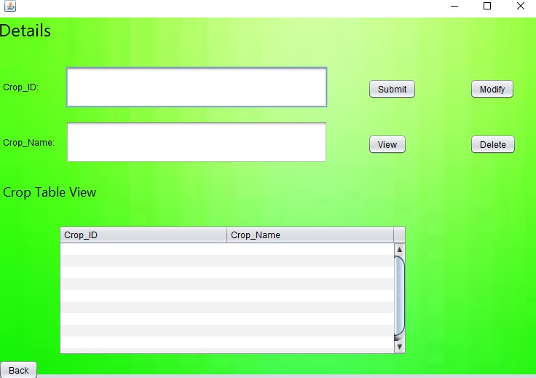

#### Diseases:‐

import java.sql.Connection; import java.sql.DriverManager; import java.sql.ResultSet; import java.sql.Statement; import javax.swing.JFrame; import javax.swing.JOptionPane;

import javax.swing.table.DefaultTableModel; public class Diseases extends javax.swing.JFrame {

public Diseases() { initComponents();

}

private void initComponents() {

jLabel1 = new javax.swing.JLabel(); jTextField1 = new javax.swing.JTextField(); jLabel2 = new javax.swing.JLabel(); jTextField2 = new javax.swing.JTextField(); jButton1 = new javax.swing.JButton(); jButton2 = new javax.swing.JButton(); jButton3 = new javax.swing.JButton(); jLabel4 = new javax.swing.JLabel(); jButton4 = new javax.swing.JButton(); jButton5 = new javax.swing.JButton(); jLabel5 = new javax.swing.JLabel();

jScrollPane1 = new javax.swing.JScrollPane(); jTable1 = new javax.swing.JTable();

jLabel3 = new javax.swing.JLabel();

setDefaultCloseOperation(javax.swing.WindowConstants.EXIT_ON_CLOSE); getContentPane().setLayout(new org.netbeans.lib.awtextra.AbsoluteLayout());

jLabel1.setText("Crop‐ID:");

getContentPane().add(jLabel1, new org.netbeans.lib.awtextra.AbsoluteConstraints(39, 62, 65, 25));

jTextField1.addActionListener(new java.awt.event.ActionListener() { public void actionPerformed(java.awt.event.ActionEvent evt) {

jTextField1ActionPerformed(evt);

}

});

getContentPane().add(jTextField1, new org.netbeans.lib.awtextra.AbsoluteConstraints(122, 50, 328, 48));

jLabel2.setText("Disease Name:");

getContentPane().add(jLabel2, new org.netbeans.lib.awtextra.AbsoluteConstraints(27, 136, ‐1, ‐1)); getContentPane().add(jTextField2, new org.netbeans.lib.awtextra.AbsoluteConstraints(122, 120, 328, 48));

jButton1.setText("Submit");

jButton1.addActionListener(new java.awt.event.ActionListener() { public void actionPerformed(java.awt.event.ActionEvent evt) {

jButton1ActionPerformed(evt);

}

});

getContentPane().add(jButton1, new org.netbeans.lib.awtextra.AbsoluteConstraints(477, 63, ‐1, ‐1));

jButton2.setText("Modify");

jButton2.addActionListener(new java.awt.event.ActionListener() { public void actionPerformed(java.awt.event.ActionEvent evt) {

jButton2ActionPerformed(evt);

}

});

getContentPane().add(jButton2, new org.netbeans.lib.awtextra.AbsoluteConstraints(477, 133, ‐1, ‐1));

jButton3.setText("Delete");

jButton3.addActionListener(new java.awt.event.ActionListener() { public void actionPerformed(java.awt.event.ActionEvent evt) {

jButton3ActionPerformed(evt);

}

});

getContentPane().add(jButton3, new org.netbeans.lib.awtextra.AbsoluteConstraints(611, 133, ‐1, ‐1));

jLabel4.setFont(new java.awt.Font("Segoe UI", 0, 24)); jLabel4.setText("Diseases");

getContentPane().add(jLabel4, new org.netbeans.lib.awtextra.AbsoluteConstraints(6, 6, 123, ‐1));

jButton4.setText("Back");

jButton4.addActionListener(new java.awt.event.ActionListener() { public void actionPerformed(java.awt.event.ActionEvent evt) {

jButton4ActionPerformed(evt);

}

});

getContentPane().add(jButton4, new org.netbeans.lib.awtextra.AbsoluteConstraints(0, 470, ‐1, ‐1));

jButton5.setText("view");

jButton5.addActionListener(new java.awt.event.ActionListener() { public void actionPerformed(java.awt.event.ActionEvent evt) {

jButton5ActionPerformed(evt);

}

});

getContentPane().add(jButton5, new org.netbeans.lib.awtextra.AbsoluteConstraints(611, 63, ‐1, ‐1));

jLabel5.setFont(new java.awt.Font("Segoe UI", 0, 18)); jLabel5.setText("Diseases Table View");

getContentPane().add(jLabel5, new org.netbeans.lib.awtextra.AbsoluteConstraints(14, 194, ‐1, ‐1));

jTable1.setModel(new javax.swing.table.DefaultTableModel( new Object [][] {

{null, null},

{null, null},

{null, null},

{null, null}

},

new String [] { "Crop‐ID", "Diseases"

}

) {

Class[] types = new Class [] { java.lang.Integer.class, java.lang.String.class

};

public Class getColumnClass(int columnIndex) { return types [columnIndex];

}

});

jScrollPane1.setViewportView(jTable1);

getContentPane().add(jScrollPane1, new org.netbeans.lib.awtextra.AbsoluteConstraints(90, 231, 470, 200));

jLabel3.setIcon(new javax.swing.ImageIcon(getClass().getResource("/images (1).jpg"))); jLabel3.setText("jLabel3");

getContentPane().add(jLabel3, new org.netbeans.lib.awtextra.AbsoluteConstraints(0, 0, 770, 650));

pack();

}

private void jButton4ActionPerformed(java.awt.event.ActionEvent evt) { dispose();

}

private void jButton1ActionPerformed(java.awt.event.ActionEvent evt) { try

{

DriverManager.registerDriver(new oracle.jdbc.driver.OracleDriver());

Connection con = (Connection) DriverManager.getConnection("jdbc:oracle:thin:@localhost:1521:XE"

,"srujana","vasavi");

Statement statement = con.createStatement();

String query = "INSERT INTO diseases VALUES(" + "'"+jTextField1.getText() + "',"+"'"+ jTextField2.getText()+"'" +")"; ResultSet rs = statement.executeQuery(query);

JOptionPane.showMessageDialog(new JFrame(), "Inserted Successfully", "INFORMATION", JOptionPane.INFORMATION_MESSAGE);

rs.close(); statement.close(); con.close();

}

catch(Exception e)

{

System.out.println(e);

}

}

private void jButton2ActionPerformed(java.awt.event.ActionEvent evt) { try

{

if(jTable1.getRowCount()==0)

{

JOptionPane.showMessageDialog(this, "Please View the table to Update", "Notice", JOptionPane.INFORMATION_MESSAGE);

}

else

{

int r = jTable1.getSelectedRow(); if(r<0)

{

JOptionPane.showMessageDialog(this, "Please select single Row from View table to Update", "Notice", JOptionPane.INFORMATION_MESSAGE);

}

else

{

DriverManager.registerDriver(new oracle.jdbc.driver.OracleDriver());

+"'";

Connection con = DriverManager.getConnection("jdbc:oracle:thin:@localhost:1521:XE" ,"srujana","vasavi"); Statement statement = con.createStatement();

String query = "UPDATE diseases SET disease='" + jTextField2.getText() + "' WHERE id ='" + jTextField1.getText()

ResultSet rs = statement.executeQuery(query);

JOptionPane.showMessageDialog(new JFrame(), "Updated Successfully", "INFORMATION",

JOptionPane.INFORMATION_MESSAGE);

rs.close(); statement.close(); con.close();

}

}

}

catch(Exception e)

{

System.out.println(e);

}

}

private void jButton3ActionPerformed(java.awt.event.ActionEvent evt) { try

{

if(jTable1.getRowCount()==0)

{

JOptionPane.showMessageDialog(this, "Please View the table to Delete", "Notice", JOptionPane.INFORMATION_MESSAGE);

}

else

{

int r = jTable1.getSelectedRow();

if(r<0)

{

JOptionPane.showMessageDialog(this, "Please select single Row from view table to Delete", "Notice", JOptionPane.INFORMATION_MESSAGE);

}

else

{

DriverManager.registerDriver(new oracle.jdbc.driver.OracleDriver());

Connection con = DriverManager.getConnection("jdbc:oracle:thin:@localhost:1521:XE" ,"srujana","vasavi"); Statement statement = con.createStatement();

String query = "DELETE from diseases where id = '" + jTextField1.getText() + "'"; ResultSet rs = statement.executeQuery(query);

JOptionPane.showMessageDialog(new JFrame(), "Deleted Successfully", "INFORMATION", JOptionPane.INFORMATION_MESSAGE);

rs.close(); statement.close(); con.close();

}

}

}

catch(Exception e)

{

System.out.println(e);

}

}

private void jButton5ActionPerformed(java.awt.event.ActionEvent evt) { try

{

DriverManager.registerDriver(new oracle.jdbc.driver.OracleDriver());

Connection con = DriverManager.getConnection("jdbc:oracle:thin:@localhost:1521:XE" ,"srujana","vasavi"); Statement statement = con.createStatement();

String query = "SELECT * FROM diseases"; ResultSet rs = statement.executeQuery(query);

DefaultTableModel model = (DefaultTableModel)jTable1.getModel(); model.setRowCount(0);

while(rs.next())

{

model.addRow(new Object[]{ rs.getString("ID"), rs.getString("disease") });

}

rs.close(); statement.close(); con.close();

}

catch(Exception e)

{

System.out.println(e);

}

}

public static void main(String args[]) { try {

for (javax.swing.UIManager.LookAndFeelInfo info : javax.swing.UIManager.getInstalledLookAndFeels()) { if ("Nimbus".equals(info.getName())) {

javax.swing.UIManager.setLookAndFeel(info.getClassName()); break;

}

}

} catch (ClassNotFoundException ex) { java.util.logging.Logger.getLogger(Diseases.class.getName()).log(java.util.logging.Level.SEVERE, null, ex);

} catch (InstantiationException ex) { java.util.logging.Logger.getLogger(Diseases.class.getName()).log(java.util.logging.Level.SEVERE, null, ex);

} catch (IllegalAccessException ex) { java.util.logging.Logger.getLogger(Diseases.class.getName()).log(java.util.logging.Level.SEVERE, null, ex);

} catch (javax.swing.UnsupportedLookAndFeelException ex) { java.util.logging.Logger.getLogger(Diseases.class.getName()).log(java.util.logging.Level.SEVERE, null, ex);

}

java.awt.EventQueue.invokeLater(new Runnable() { public void run() {

new Diseases().setVisible(true);

}

});

}

private javax.swing.JButton jButton1; private javax.swing.JButton jButton2; private javax.swing.JButton jButton3; private javax.swing.JButton jButton4; private javax.swing.JButton jButton5; private javax.swing.JLabel jLabel1; private javax.swing.JLabel jLabel2; private javax.swing.JLabel jLabel3; private javax.swing.JLabel jLabel4; private javax.swing.JLabel jLabel5;

private javax.swing.JScrollPane jScrollPane1; private javax.swing.JTable jTable1;

private javax.swing.JTextField jTextField1; private javax.swing.JTextField jTextField2;

}

Disease‐Form

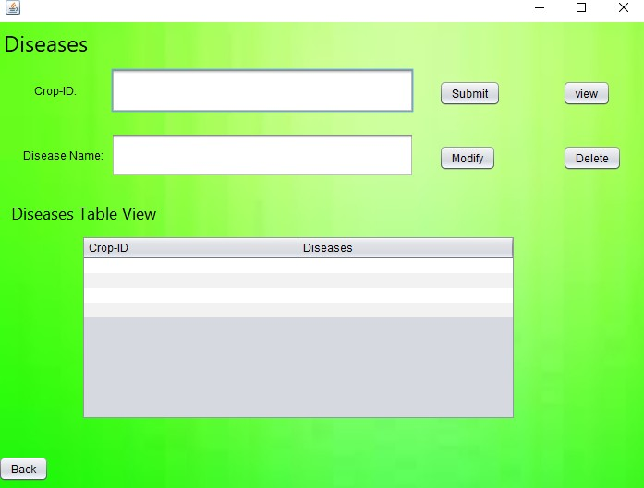

Factors.java

import java.sql.Connection; import java.sql.DriverManager; import java.sql.ResultSet; import java.sql.Statement; import javax.swing.JFrame; import javax.swing.JOptionPane;

import javax.swing.table.DefaultTableModel; public class Factors extends javax.swing.JFrame {

public Factors() { initComponents();

}

private void initComponents() { jLabel1 = new javax.swing.JLabel(); jLabel2 = new javax.swing.JLabel(); jLabel3 = new javax.swing.JLabel();

jButton1 = new javax.swing.JButton(); jButton2 = new javax.swing.JButton(); jButton3 = new javax.swing.JButton(); jTextField1 = new javax.swing.JTextField(); jTextField2 = new javax.swing.JTextField(); jButton4 = new javax.swing.JButton(); jButton5 = new javax.swing.JButton(); jLabel4 = new javax.swing.JLabel(); jScrollPane1 = new javax.swing.JScrollPane(); jTable1 = new javax.swing.JTable();

jLabel5 = new javax.swing.JLabel(); setDefaultCloseOperation(javax.swing.WindowConstants.EXIT_ON_CLOSE); getContentPane().setLayout(new org.netbeans.lib.awtextra.AbsoluteLayout()); jLabel1.setFont(new java.awt.Font("Segoe UI", 0, 24)); jLabel1.setText("Factors");

getContentPane().add(jLabel1, new org.netbeans.lib.awtextra.AbsoluteConstraints(0, 0, 93, ‐1));

jLabel2.setText("Crop‐ID:");

getContentPane().add(jLabel2, new org.netbeans.lib.awtextra.AbsoluteConstraints(28, 77, ‐1, ‐1)); jLabel3.setText("Factor:");

getContentPane().add(jLabel3, new org.netbeans.lib.awtextra.AbsoluteConstraints(37, 163, ‐1, ‐1));

jButton1.setText("Submit");

jButton1.addActionListener(new java.awt.event.ActionListener() { public void actionPerformed(java.awt.event.ActionEvent evt) {

jButton1ActionPerformed(evt);

}

});

getContentPane().add(jButton1, new org.netbeans.lib.awtextra.AbsoluteConstraints(494, 73, ‐1, ‐1));

jButton2.setText("Modify");

jButton2.addActionListener(new java.awt.event.ActionListener() { public void actionPerformed(java.awt.event.ActionEvent evt) {

jButton2ActionPerformed(evt);

}

});

getContentPane().add(jButton2, new org.netbeans.lib.awtextra.AbsoluteConstraints(494, 160, ‐1, ‐1));

jButton3.setText("Delete");

jButton3.addActionListener(new java.awt.event.ActionListener() { public void actionPerformed(java.awt.event.ActionEvent evt) {

jButton3ActionPerformed(evt);

}

});

getContentPane().add(jButton3, new org.netbeans.lib.awtextra.AbsoluteConstraints(633, 160, ‐1, ‐1));

jTextField1.addActionListener(new java.awt.event.ActionListener() { public void actionPerformed(java.awt.event.ActionEvent evt) {

jTextField1ActionPerformed(evt);

}

});

getContentPane().add(jTextField1, new org.netbeans.lib.awtextra.AbsoluteConstraints(100, 53, 319, 64));

getContentPane().add(jTextField2, new org.netbeans.lib.awtextra.AbsoluteConstraints(100, 138, 319, 66));

jButton4.setText("Back");

jButton4.addActionListener(new java.awt.event.ActionListener() { public void actionPerformed(java.awt.event.ActionEvent evt) {

jButton4ActionPerformed(evt);

}

});

getContentPane().add(jButton4, new org.netbeans.lib.awtextra.AbsoluteConstraints(0, 498, ‐1, ‐1));

jButton5.setText("View");

jButton5.addActionListener(new java.awt.event.ActionListener() { public void actionPerformed(java.awt.event.ActionEvent evt) {

jButton5ActionPerformed(evt);

}

});

getContentPane().add(jButton5, new org.netbeans.lib.awtextra.AbsoluteConstraints(633, 73, ‐1, ‐1));

jLabel4.setFont(new java.awt.Font("Segoe UI", 0, 18)); jLabel4.setText("Factors Table View");

getContentPane().add(jLabel4, new org.netbeans.lib.awtextra.AbsoluteConstraints(16, 222, ‐1, ‐1));

jTable1.setModel(new javax.swing.table.DefaultTableModel( new Object [][] {

{null, null},

{null, null},

{null, null},

{null, null}

},

new String [] { "Crop_id", "Factor"

}

) {

Class[] types = new Class [] { java.lang.Integer.class, java.lang.Integer.class

};

public Class getColumnClass(int columnIndex) { return types [columnIndex];

}

});

jScrollPane1.setViewportView(jTable1);

getContentPane().add(jScrollPane1, new org.netbeans.lib.awtextra.AbsoluteConstraints(76, 265, ‐1, 212));

jLabel5.setIcon(new javax.swing.ImageIcon(getClass().getResource("/images (1).jpg"))); jLabel5.setText("jLabel5");

getContentPane().add(jLabel5, new org.netbeans.lib.awtextra.AbsoluteConstraints(0, 0, 750, 520));

pack();

}

private void jButton4ActionPerformed(java.awt.event.ActionEvent evt) { dispose();

}

private void jTextField1ActionPerformed(java.awt.event.ActionEvent evt) {

}

private void jButton1ActionPerformed(java.awt.event.ActionEvent evt) { try

{

DriverManager.registerDriver(new oracle.jdbc.driver.OracleDriver());

Connection con = (Connection) DriverManager.getConnection("jdbc:oracle:thin:@localhost:1521:XE"

,"srujana","vasavi");

Statement statement = con.createStatement();

String query = "INSERT INTO FACTORS VALUES(" + "'"+jTextField1.getText() + "',"+"'"+ jTextField2.getText()+"'" +")"; ResultSet rs = statement.executeQuery(query);

JOptionPane.showMessageDialog(new JFrame(), "Inserted Successfully", "INFORMATION", JOptionPane.INFORMATION_MESSAGE);

rs.close(); statement.close(); con.close();

}

catch(Exception e)

{

JOptionPane.showMessageDialog(new JFrame(),e, "ERROR", JOptionPane.ERROR_MESSAGE);

}

}

private void jButton3ActionPerformed(java.awt.event.ActionEvent evt) { try

{

if(jTable1.getRowCount()==0)

{

JOptionPane.showMessageDialog(this, "Please View the table to Delete", "Notice", JOptionPane.INFORMATION_MESSAGE);

}

else

{

int r = jTable1.getSelectedRow();

if(r<0)

{

JOptionPane.showMessageDialog(this, "Please select single Row from view table to Delete", "Notice", JOptionPane.INFORMATION_MESSAGE);

}

else

{

DriverManager.registerDriver(new oracle.jdbc.driver.OracleDriver());

Connection con = DriverManager.getConnection("jdbc:oracle:thin:@localhost:1521:XE" ,"srujana","vasavi");

Statement statement = con.createStatement();

String query = "DELETE from factors where id = '" + jTextField1.getText() + "'"; ResultSet rs = statement.executeQuery(query);

JOptionPane.showMessageDialog(new JFrame(), "Deleted Successfully", "INFORMATION", JOptionPane.INFORMATION_MESSAGE);

rs.close(); statement.close(); con.close();

}

}

}

catch(Exception e)

{

JOptionPane.showMessageDialog(new JFrame(),e, "INFORMATION", JOptionPane.INFORMATION_MESSAGE);

}

}

private void jButton2ActionPerformed(java.awt.event.ActionEvent evt) { try

{

if(jTable1.getRowCount()==0)

{

JOptionPane.showMessageDialog(this, "Please View the table to Update", "Notice", JOptionPane.INFORMATION_MESSAGE);

}

else

{

int r = jTable1.getSelectedRow();

if(r<0)

{

JOptionPane.showMessageDialog(this, "Please select single Row from View table to Update", "Notice", JOptionPane.INFORMATION_MESSAGE);

}

else

{

DriverManager.registerDriver(new oracle.jdbc.driver.OracleDriver());

Connection con = DriverManager.getConnection("jdbc:oracle:thin:@localhost:1521:XE" ,"srujana","vasavi"); Statement statement = con.createStatement();

String query = "UPDATE factors SET factor='" + jTextField2.getText() + "' WHERE id ='" + jTextField1.getText() +"'"; ResultSet rs = statement.executeQuery(query);

JOptionPane.showMessageDialog(new JFrame(), "Updated Successfully", "INFORMATION", JOptionPane.INFORMATION_MESSAGE);

rs.close(); statement.close(); con.close();

}

}

}

catch(Exception e)

{

JOptionPane.showMessageDialog(new JFrame(),e, "INFORMATION", JOptionPane.INFORMATION_MESSAGE);

}

}

private void jButton5ActionPerformed(java.awt.event.ActionEvent evt) { try

{

DriverManager.registerDriver(new oracle.jdbc.driver.OracleDriver());

Connection con = DriverManager.getConnection("jdbc:oracle:thin:@localhost:1521:XE" ,"srujana","vasavi"); Statement statement = con.createStatement();

String query = "SELECT * FROM factors"; ResultSet rs = statement.executeQuery(query);

DefaultTableModel model = (DefaultTableModel)jTable1.getModel(); model.setRowCount(0);

while(rs.next())

{

model.addRow(new Object[]{ rs.getString("ID"), rs.getString("factor") });

}

rs.close(); statement.close(); con.close();

}

catch(Exception e)

{

JOptionPane.showMessageDialog(new JFrame(),e, "INFORMATION", JOptionPane.INFORMATION_MESSAGE);

}

}

public static void main(String args[]) { try {

for (javax.swing.UIManager.LookAndFeelInfo info : javax.swing.UIManager.getInstalledLookAndFeels()) { if ("Nimbus".equals(info.getName())) {

javax.swing.UIManager.setLookAndFeel(info.getClassName()); break;

}

}

} catch (ClassNotFoundException ex) { java.util.logging.Logger.getLogger(Factors.class.getName()).log(java.util.logging.Level.SEVERE, null, ex);

} catch (InstantiationException ex) { java.util.logging.Logger.getLogger(Factors.class.getName()).log(java.util.logging.Level.SEVERE, null, ex);

} catch (IllegalAccessException ex) { java.util.logging.Logger.getLogger(Factors.class.getName()).log(java.util.logging.Level.SEVERE, null, ex);

} catch (javax.swing.UnsupportedLookAndFeelException ex) { java.util.logging.Logger.getLogger(Factors.class.getName()).log(java.util.logging.Level.SEVERE, null, ex);

}

java.awt.EventQueue.invokeLater(new Runnable() { public void run() {

new Factors().setVisible(true);

}

});

}

private javax.swing.JButton jButton1; private javax.swing.JButton jButton2; private javax.swing.JButton jButton3; private javax.swing.JButton jButton4; private javax.swing.JButton jButton5; private javax.swing.JLabel jLabel1; private javax.swing.JLabel jLabel2; private javax.swing.JLabel jLabel3; private javax.swing.JLabel jLabel4; private javax.swing.JLabel jLabel5;

private javax.swing.JScrollPane jScrollPane1; private javax.swing.JTable jTable1;

private javax.swing.JTextField jTextField1; private javax.swing.JTextField jTextField2;

}

Factors‐Form:

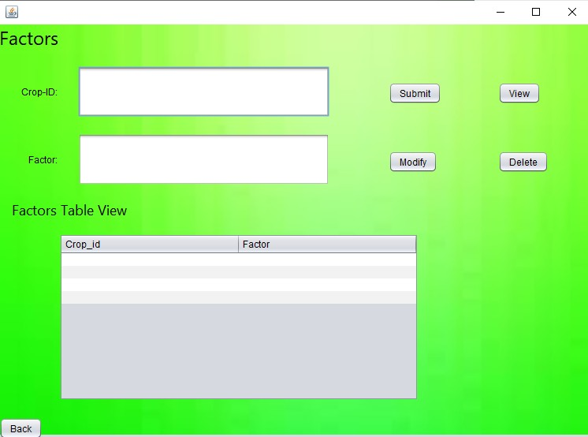

Symptoms.java

import java.sql.Connection; import java.sql.DriverManager; import java.sql.ResultSet; import java.sql.Statement; import javax.swing.JFrame; import javax.swing.JOptionPane;

import javax.swing.table.DefaultTableModel;

public class Symptoms extends javax.swing.JFrame { public Symptoms() {

initComponents();

}

private void initComponents() {

jButton4 = new javax.swing.JButton(); jLabel1 = new javax.swing.JLabel(); jLabel2 = new javax.swing.JLabel(); jTextField1 = new javax.swing.JTextField(); jLabel3 = new javax.swing.JLabel(); jTextField2 = new javax.swing.JTextField(); jLabel4 = new javax.swing.JLabel(); jTextField3 = new javax.swing.JTextField(); jLabel5 = new javax.swing.JLabel(); jTextField4 = new javax.swing.JTextField(); jButton1 = new javax.swing.JButton(); jButton2 = new javax.swing.JButton(); jButton3 = new javax.swing.JButton(); jButton5 = new javax.swing.JButton(); jButton6 = new javax.swing.JButton(); jLabel6 = new javax.swing.JLabel();

jScrollPane1 = new javax.swing.JScrollPane(); jTable1 = new javax.swing.JTable();

jLabel7 = new javax.swing.JLabel(); jButton4.setText("jButton4");

setDefaultCloseOperation(javax.swing.WindowConstants.EXIT_ON_CLOSE); getContentPane().setLayout(new org.netbeans.lib.awtextra.AbsoluteLayout());

jLabel1.setFont(new java.awt.Font("Segoe UI", 0, 24)); jLabel1.setText("Symptoms");

getContentPane().add(jLabel1, new org.netbeans.lib.awtextra.AbsoluteConstraints(0, 0, 134, ‐1));

jLabel2.setText("Crop_ID:");

getContentPane().add(jLabel2, new org.netbeans.lib.awtextra.AbsoluteConstraints(42, 64, ‐1, ‐1));

jTextField1.addActionListener(new java.awt.event.ActionListener() { public void actionPerformed(java.awt.event.ActionEvent evt) {

jTextField1ActionPerformed(evt);

}

});

getContentPane().add(jTextField1, new org.netbeans.lib.awtextra.AbsoluteConstraints(99, 55, 445, 34));

jLabel3.setText("High:");

getContentPane().add(jLabel3, new org.netbeans.lib.awtextra.AbsoluteConstraints(42, 122, 45, ‐1));

getContentPane().add(jTextField2, new org.netbeans.lib.awtextra.AbsoluteConstraints(99, 101, 445, 58));

jLabel4.setText("Low:");

getContentPane().add(jLabel4, new org.netbeans.lib.awtextra.AbsoluteConstraints(42, 189, ‐1, ‐1)); getContentPane().add(jTextField3, new org.netbeans.lib.awtextra.AbsoluteConstraints(99, 171, 445, 59));

jLabel5.setText("Medium:");

getContentPane().add(jLabel5, new org.netbeans.lib.awtextra.AbsoluteConstraints(42, 231, ‐1, ‐1)); getContentPane().add(jTextField4, new org.netbeans.lib.awtextra.AbsoluteConstraints(102, 242, 445, 58));

jButton1.setText("Submit");

jButton1.addActionListener(new java.awt.event.ActionListener() { public void actionPerformed(java.awt.event.ActionEvent evt) {

jButton1ActionPerformed(evt);

}

});

getContentPane().add(jButton1, new org.netbeans.lib.awtextra.AbsoluteConstraints(627, 119, ‐1, ‐1));

jButton2.setText("Modify");

jButton2.addActionListener(new java.awt.event.ActionListener() { public void actionPerformed(java.awt.event.ActionEvent evt) {

jButton2ActionPerformed(evt);

}

});

getContentPane().add(jButton2, new org.netbeans.lib.awtextra.AbsoluteConstraints(627, 234, ‐1, ‐1));

jButton3.setText("Delete");

jButton3.addActionListener(new java.awt.event.ActionListener() { public void actionPerformed(java.awt.event.ActionEvent evt) {

jButton3ActionPerformed(evt);

}

});

getContentPane().add(jButton3, new org.netbeans.lib.awtextra.AbsoluteConstraints(779, 234, ‐1, ‐1));

jButton5.setText("Back");

jButton5.addActionListener(new java.awt.event.ActionListener() {

public void actionPerformed(java.awt.event.ActionEvent evt) { jButton5ActionPerformed(evt);

}

});

getContentPane().add(jButton5, new org.netbeans.lib.awtextra.AbsoluteConstraints(0, 542, ‐1, ‐1));

jButton6.setText("View");

jButton6.addActionListener(new java.awt.event.ActionListener() { public void actionPerformed(java.awt.event.ActionEvent evt) {

jButton6ActionPerformed(evt);

}

});

getContentPane().add(jButton6, new org.netbeans.lib.awtextra.AbsoluteConstraints(779, 119, ‐1, ‐1));

jLabel6.setFont(new java.awt.Font("Segoe UI", 0, 18)); jLabel6.setText("Symptoms Table View");

getContentPane().add(jLabel6, new org.netbeans.lib.awtextra.AbsoluteConstraints(0, 306, ‐1, ‐1));

jTable1.setModel(new javax.swing.table.DefaultTableModel( new Object [][] {

{null, null, null, null},

{null, null, null, null},

{null, null, null, null},

{null, null, null, null}

},

new String [] {

"Crop_ID", "High", "Low", "Medium"

}

) {

Class[] types = new Class [] {

java.lang.Integer.class, java.lang.String.class, java.lang.String.class, java.lang.String.class

};

public Class getColumnClass(int columnIndex) { return types [columnIndex];

}

});

jScrollPane1.setViewportView(jTable1);

getContentPane().add(jScrollPane1, new org.netbeans.lib.awtextra.AbsoluteConstraints(99, 337, ‐1, 186));

jLabel7.setIcon(new javax.swing.ImageIcon(getClass().getResource("/images (1).jpg"))); jLabel7.setText("jLabel7");

getContentPane().add(jLabel7, new org.netbeans.lib.awtextra.AbsoluteConstraints(0, 0, 870, 610));

pack();

}

private void jButton5ActionPerformed(java.awt.event.ActionEvent evt) {//GEN‐FIRST:event_jButton5ActionPerformed dispose();

}

private void jButton1ActionPerformed(java.awt.event.ActionEvent evt) {//GEN‐FIRST:event_jButton1ActionPerformed try

{

DriverManager.registerDriver(new oracle.jdbc.driver.OracleDriver());

Connection con = (Connection) DriverManager.getConnection("jdbc:oracle:thin:@localhost:1521:XE"

,"srujana","vasavi");

Statement statement = con.createStatement();

String query = "INSERT INTO symptoms values("+"'"+jTextField1.getText()+"' , "+"'"+jTextField2.getText()+"', "+"'"+ jTextField3.getText()+"', "+"'"+ jTextField4.getText()+"')";

ResultSet rs = statement.executeQuery(query);

JOptionPane.showMessageDialog(new JFrame(), "Inserted Successfully", "INFORMATION", JOptionPane.INFORMATION_MESSAGE);

rs.close(); statement.close(); con.close();

}

catch(Exception e)

{

System.out.println(e);

}

}

private void jButton2ActionPerformed(java.awt.event.ActionEvent evt) { try

{

if(jTable1.getRowCount()==0)

{

JOptionPane.showMessageDialog(this, "Please View the table to Update", "Notice", JOptionPane.INFORMATION_MESSAGE);

}

else

{

int r = jTable1.getSelectedRow();

if(r<0)

{

JOptionPane.showMessageDialog(this, "Please select single Row from View table to Update", "Notice", JOptionPane.INFORMATION_MESSAGE);

}

else

{

DriverManager.registerDriver(new oracle.jdbc.driver.OracleDriver());

Connection con = DriverManager.getConnection("jdbc:oracle:thin:@localhost:1521:XE" ,"srujana","vasavi"); Statement statement = con.createStatement();

String query = "UPDATE symptoms SET high=" +"'"+ jTextField2.getText() +"',low=" +"'"+ jTextField3.getText() +"', medium ="+" '"+ jTextField4.getText() +"' WHERE ID =+" + jTextField1.getText();

ResultSet rs = statement.executeQuery(query);

JOptionPane.showMessageDialog(new JFrame(), "Updated Successfully", "INFORMATION", JOptionPane.INFORMATION_MESSAGE);

rs.close(); statement.close(); con.close();

}

}

}

catch(Exception e)

{

System.out.println(e);

}

}

private void jButton3ActionPerformed(java.awt.event.ActionEvent evt) { try

{

if(jTable1.getRowCount()==0)

{

JOptionPane.showMessageDialog(this, "Please View the table to Delete", "Notice", JOptionPane.INFORMATION_MESSAGE);

}

else

{

int r = jTable1.getSelectedRow();

if(r<0)

{

JOptionPane.showMessageDialog(this, "Please select single Row from view table to Delete", "Notice", JOptionPane.INFORMATION_MESSAGE);

}

else

{

DriverManager.registerDriver(new oracle.jdbc.driver.OracleDriver());

Connection con = DriverManager.getConnection("jdbc:oracle:thin:@localhost:1521:XE" ,"srujana","vasavi");

Statement statement = con.createStatement();

String query = "DELETE from symptoms where id = '" + jTextField1.getText() + "'"; ResultSet rs = statement.executeQuery(query);

JOptionPane.showMessageDialog(new JFrame(), "Deleted Successfully", "INFORMATION", JOptionPane.INFORMATION_MESSAGE);

rs.close(); statement.close(); con.close();

}

}

}

catch(Exception e)

{

System.out.println(e);

}

}

private void jButton6ActionPerformed(java.awt.event.ActionEvent evt) { try

{

DriverManager.registerDriver(new oracle.jdbc.driver.OracleDriver());

Connection con = DriverManager.getConnection("jdbc:oracle:thin:@localhost:1521:XE" ,"srujana","vasavi"); Statement statement = con.createStatements();

String query = "SELECT * FROM symptoms"; ResultSet rs = statement.executeQuery(query);

DefaultTableModel model = (DefaultTableModel)jTable1.getModel(); model.setRowCount(0);

while(rs.next())

{

});

model.addRow(new Object[]{ rs.getString("ID"), rs.getString("High"),rs.getString("Low"),rs.getString("Medium")

}

rs.close(); statement.close(); con.close();

}

catch(Exception e)

{

System.out.println(e);

}

}

public static void main(String args[]) { try {

for (javax.swing.UIManager.LookAndFeelInfo info : javax.swing.UIManager.getInstalledLookAndFeels()) { if ("Nimbus".equals(info.getName())) {

javax.swing.UIManager.setLookAndFeel(info.getClassName()); break;

}

}

} catch (ClassNotFoundException ex) { java.util.logging.Logger.getLogger(Symptoms.class.getName()).log(java.util.logging.Level.SEVERE, null, ex);

} catch (InstantiationException ex) { java.util.logging.Logger.getLogger(Symptoms.class.getName()).log(java.util.logging.Level.SEVERE, null, ex);

} catch (IllegalAccessException ex) { java.util.logging.Logger.getLogger(Symptoms.class.getName()).log(java.util.logging.Level.SEVERE, null, ex);

} catch (javax.swing.UnsupportedLookAndFeelException ex) { java.util.logging.Logger.getLogger(Symptoms.class.getName()).log(java.util.logging.Level.SEVERE, null, ex);

}

java.awt.EventQueue.invokeLater(new Runnable() { public void run() {

new Symptoms().setVisible(true);

}

});

}

private javax.swing.JButton jButton1; private javax.swing.JButton jButton2; private javax.swing.JButton jButton3; private javax.swing.JButton jButton4; private javax.swing.JButton jButton5; private javax.swing.JButton jButton6; private javax.swing.JLabel jLabel1; private javax.swing.JLabel jLabel2; private javax.swing.JLabel jLabel3; private javax.swing.JLabel jLabel4; private javax.swing.JLabel jLabel5; private javax.swing.JLabel jLabel6; private javax.swing.JLabel jLabel7;

private javax.swing.JScrollPane jScrollPane1; private javax.swing.JTable jTable1;

private javax.swing.JTextField jTextField1; private javax.swing.JTextField jTextField2; private javax.swing.JTextField jTextField3; private javax.swing.JTextField jTextField4;

}

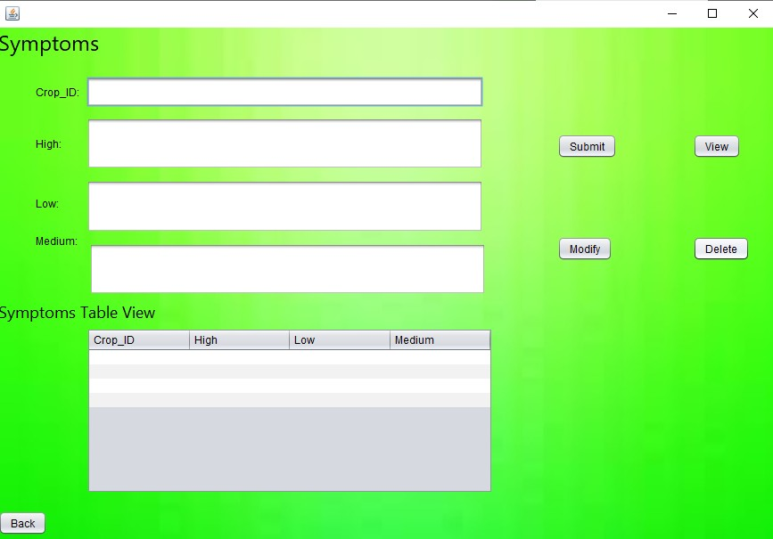

Check_severity:‐

import java.sql.Connection; import java.sql.DriverManager; import java.sql.ResultSet; import java.sql.Statement; import javax.swing.JFrame; import javax.swing.JOptionPane;

import javax.swing.table.DefaultTableModel;

public class Check_severity extends javax.swing.JFrame { public Check_severity() {

initComponents();

}

private void initComponents() {

jLabel1 = new javax.swing.JLabel(); jTextField1 = new javax.swing.JTextField();

jButton1 = new javax.swing.JButton(); jScrollPane1 = new javax.swing.JScrollPane(); jTable1 = new javax.swing.JTable();

jLabel4 = new javax.swing.JLabel(); jLabel5 = new javax.swing.JLabel(); jLabel6 = new javax.swing.JLabel(); jLabel7 = new javax.swing.JLabel(); jLabel2 = new javax.swing.JLabel(); jLabel3 = new javax.swing.JLabel(); jLabel8 = new javax.swing.JLabel(); jLabel9 = new javax.swing.JLabel(); jLabel10 = new javax.swing.JLabel(); jButton2 = new javax.swing.JButton(); jLabel11 = new javax.swing.JLabel();

setDefaultCloseOperation(javax.swing.WindowConstants.EXIT_ON_CLOSE); getContentPane().setLayout(new org.netbeans.lib.awtextra.AbsoluteLayout());

jLabel1.setText("Crop_ID:");

getContentPane().add(jLabel1, new org.netbeans.lib.awtextra.AbsoluteConstraints(57, 289, 70, 34));

getContentPane().add(jTextField1, new org.netbeans.lib.awtextra.AbsoluteConstraints(133, 289, 283, 34));

jButton1.setText("check");

jButton1.addActionListener(new java.awt.event.ActionListener() { public void actionPerformed(java.awt.event.ActionEvent evt) {

jButton1ActionPerformed(evt);

}

});

getContentPane().add(jButton1, new org.netbeans.lib.awtextra.AbsoluteConstraints(434, 295, ‐1, ‐1));

jTable1.setModel(new javax.swing.table.DefaultTableModel( new Object [][] {

{null, null, null, null},

{null, null, null, null},

{null, null, null, null},

{null, null, null, null}

},

new String [] {

"Crop_ID", "High", "Low", "Medium"

}

) {

Class[] types = new Class [] {

java.lang.Integer.class, java.lang.String.class, java.lang.String.class, java.lang.String.class

};

public Class getColumnClass(int columnIndex) { return types [columnIndex];

}

});

jScrollPane1.setViewportView(jTable1);

getContentPane().add(jScrollPane1, new org.netbeans.lib.awtextra.AbsoluteConstraints(54, 352, 490, 135)); jLabel4.setText("1.Type crop_ID");

getContentPane().add(jLabel4, new org.netbeans.lib.awtextra.AbsoluteConstraints(28, 16, ‐1, ‐1));

jLabel5.setText("2.click on check");

getContentPane().add(jLabel5, new org.netbeans.lib.awtextra.AbsoluteConstraints(28, 44, ‐1, ‐1));

jLabel6.setText("3.Check the symptoms in the table ");

getContentPane().add(jLabel6, new org.netbeans.lib.awtextra.AbsoluteConstraints(28, 72, ‐1, ‐1));

jLabel7.setText("i. if your crop symptom is in HIGH column ");

getContentPane().add(jLabel7, new org.netbeans.lib.awtextra.AbsoluteConstraints(57, 100, ‐1, ‐1));

jLabel2.setFont(new java.awt.Font("Segoe UI", 1, 14));

jLabel2.setForeground(new java.awt.Color(255, 0, 51)); jLabel2.setText("Then your crop disease severity is HIGH");

getContentPane().add(jLabel2, new org.netbeans.lib.awtextra.AbsoluteConstraints(96, 122, ‐1, ‐1));

jLabel3.setText("ii.If your crop symptoms is in LOW column");

getContentPane().add(jLabel3, new org.netbeans.lib.awtextra.AbsoluteConstraints(57, 150, ‐1, ‐1));

jLabel8.setFont(new java.awt.Font("Segoe UI", 1, 14));

jLabel8.setForeground(new java.awt.Color(0, 204, 51)); jLabel8.setText("Then your crop disease severity is LOW");

getContentPane().add(jLabel8, new org.netbeans.lib.awtextra.AbsoluteConstraints(97, 178, ‐1, ‐1));

jLabel9.setText("ii.If your crop symptoms is in MEDIUM column");

getContentPane().add(jLabel9, new org.netbeans.lib.awtextra.AbsoluteConstraints(57, 210, ‐1, ‐1));

jLabel10.setFont(new java.awt.Font("Segoe UI", 1, 14));

jLabel10.setForeground(new java.awt.Color(153, 153, 0)); jLabel10.setText("Then your crop disease severity is MEDIUM");

getContentPane().add(jLabel10, new org.netbeans.lib.awtextra.AbsoluteConstraints(103, 238, ‐1, ‐1));

jButton2.setText("Back");

jButton2.addActionListener(new java.awt.event.ActionListener() { public void actionPerformed(java.awt.event.ActionEvent evt) {

jButton2ActionPerformed(evt);

}

});

getContentPane().add(jButton2, new org.netbeans.lib.awtextra.AbsoluteConstraints(6, 515, ‐1, ‐1));

jLabel11.setIcon(new javax.swing.ImageIcon(getClass().getResource("/download.png"))); jLabel11.setText("jLabel11");

getContentPane().add(jLabel11, new org.netbeans.lib.awtextra.AbsoluteConstraints(0, 0, 590, 540));

pack();

}

private void jButton1ActionPerformed(java.awt.event.ActionEvent evt) { try

{

DriverManager.registerDriver(new oracle.jdbc.driver.OracleDriver());

Connection con = DriverManager.getConnection("jdbc:oracle:thin:@localhost:1521:XE" ,"srujana","vasavi"); Statement statement = con.createStatement();

String query = "SELECT * FROM symptoms WHERE id ='" + jTextField1.getText() +"'"; ResultSet rs = statement.executeQuery(query);

DefaultTableModel model = (DefaultTableModel)jTable1.getModel(); model.setRowCount(0);

while(rs.next())

{

});

model.addRow(new Object[]{ rs.getString("ID"), rs.getString("High"),rs.getString("Low"),rs.getString("Medium")

}

rs.close(); statement.close(); con.close();

}

catch(Exception e)

{

JOptionPane.showMessageDialog(new JFrame(),e, "INFORMATION", JOptionPane.INFORMATION_MESSAGE);

}

}

private void jButton2ActionPerformed(java.awt.event.ActionEvent evt) { dispose();

}

public static void main(String args[]) { try {

for (javax.swing.UIManager.LookAndFeelInfo info : javax.swing.UIManager.getInstalledLookAndFeels()) { if ("Nimbus".equals(info.getName())) {

javax.swing.UIManager.setLookAndFeel(info.getClassName()); break;

}

}

} catch (ClassNotFoundException ex) { java.util.logging.Logger.getLogger(Check_severity.class.getName()).log(java.util.logging.Level.SEVERE, null, ex);

} catch (InstantiationException ex) { java.util.logging.Logger.getLogger(Check_severity.class.getName()).log(java.util.logging.Level.SEVERE, null, ex);

} catch (IllegalAccessException ex) { java.util.logging.Logger.getLogger(Check_severity.class.getName()).log(java.util.logging.Level.SEVERE, null, ex);

} catch (javax.swing.UnsupportedLookAndFeelException ex) { java.util.logging.Logger.getLogger(Check_severity.class.getName()).log(java.util.logging.Level.SEVERE, null, ex);

}

java.awt.EventQueue.invokeLater(new Runnable() { public void run() {

new Check_severity().setVisible(true);

}

});

}

private javax.swing.JButton jButton1; private javax.swing.JButton jButton2; private javax.swing.JLabel jLabel1; private javax.swing.JLabel jLabel10; private javax.swing.JLabel jLabel11; private javax.swing.JLabel jLabel2; private javax.swing.JLabel jLabel3; private javax.swing.JLabel jLabel4; private javax.swing.JLabel jLabel5; private javax.swing.JLabel jLabel6; private javax.swing.JLabel jLabel7; private javax.swing.JLabel jLabel8; private javax.swing.JLabel jLabel9;

private javax.swing.JScrollPane jScrollPane1; private javax.swing.JTable jTable1;

private javax.swing.JTextField jTextField1;

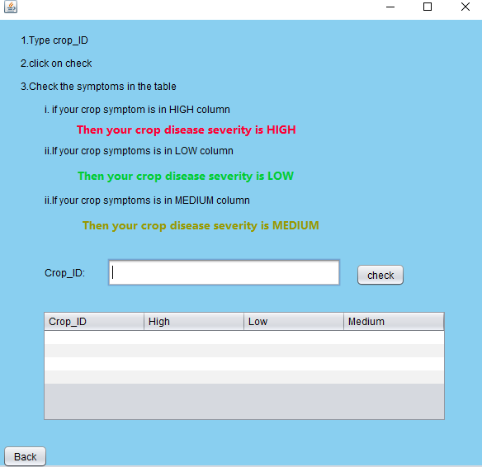}

**TESTING**

###### Home page‐

In the home page user can find 2 buttons in which user need to click on check severity button to know the disease severity Of the crop .Admin can click on the button edit data so that admin can edit data in tables.

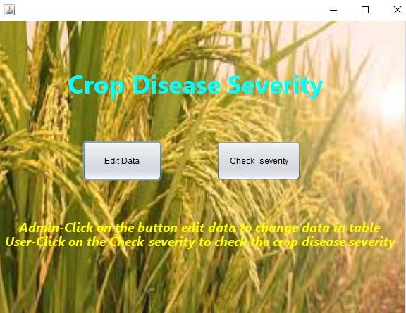

###### Edit Data:

If the admin click on Edit data then a other form opens which contain four buttons named crop, disease, factors, symptoms. These four are the tables which admin can edit data.

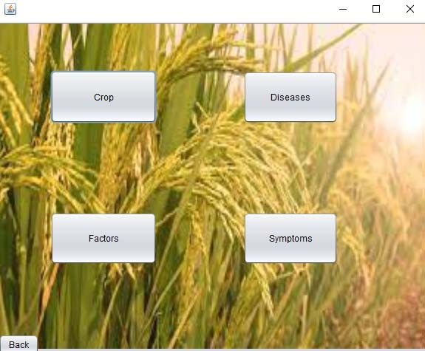

Crop:

In the crop there will be two text fields one is crop_ID and other is crop_name.Admin can click on the buttons to modify submit and delete the data. crop_ID should be integer and crop name must be a string.

###### Insert option:‐

If Crop_ID(primary key) is not repeated then it get inserted successfully .

If Crop_ID is repeated(primary key can’t have multiple values) then it show error message.

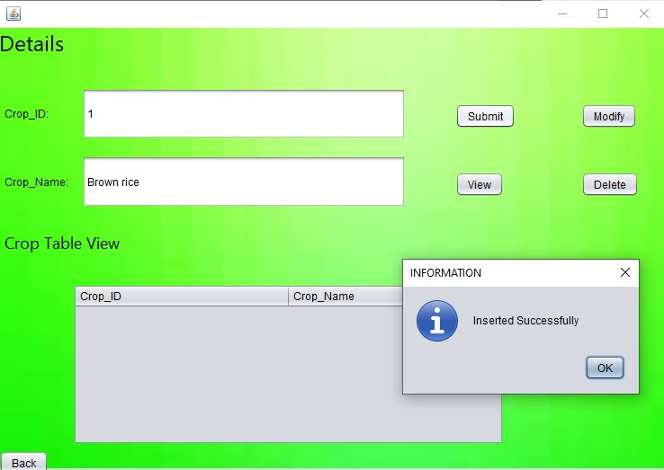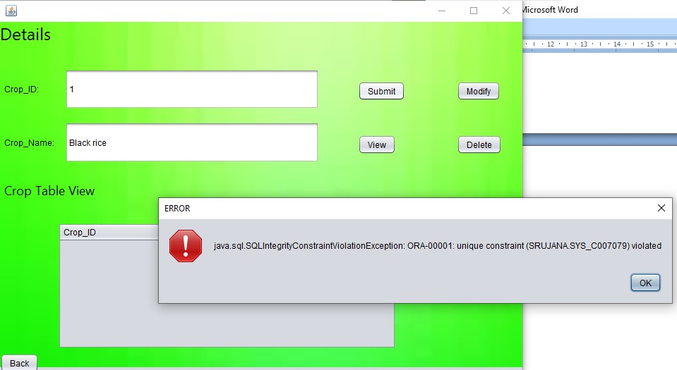

###### Inserted:

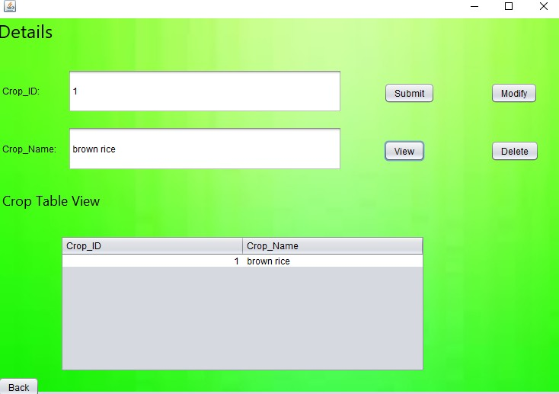

**Modify Option:**

To modify the data first click on view button and select a row which is to be modified and modify the data in that text field . If we type in text field and enter data directly then it will display a notice box.

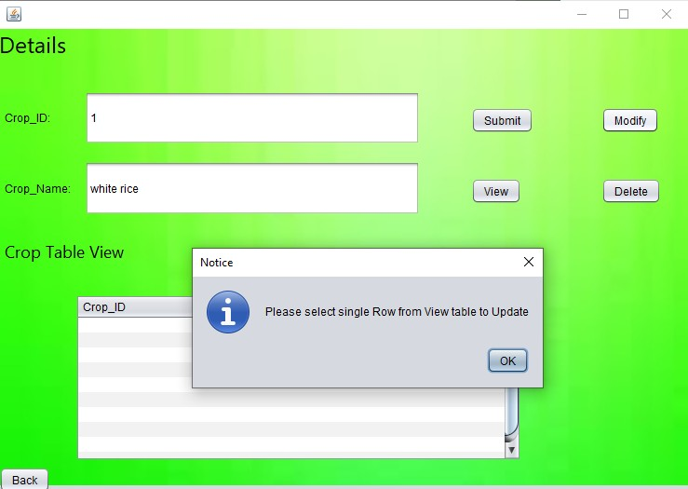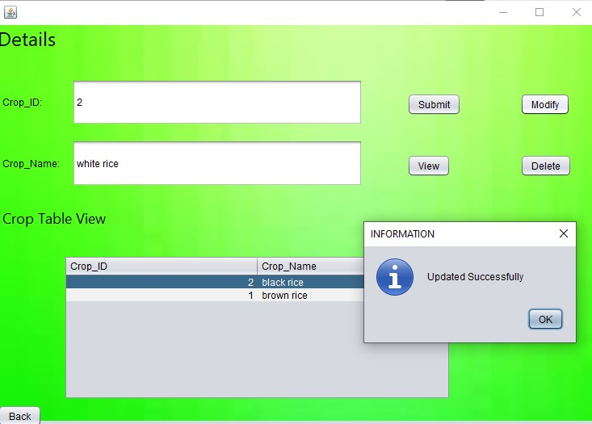

###### Modified:

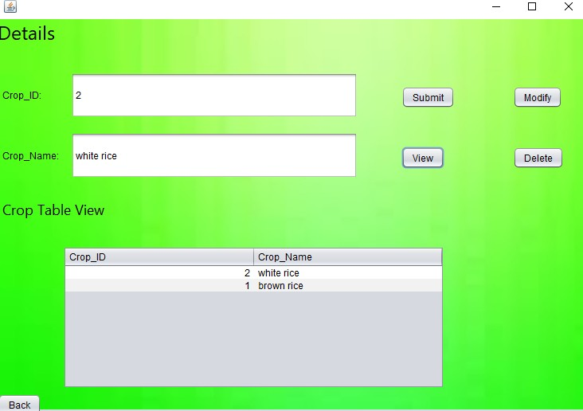

**View option:‐**

If view button is clicked then admin can view the data in the table.

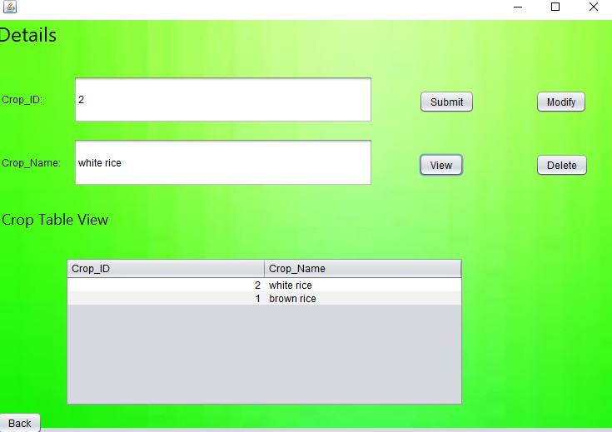

###### Delete option:

To delete the data first click on view button and select a row which is to be deleted. If we type in text field and enter data to delete directly then it will display a notice box.

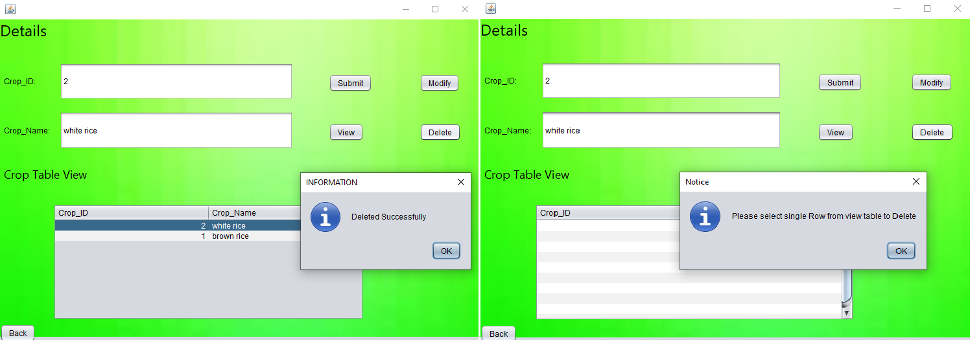

###### Deleted:

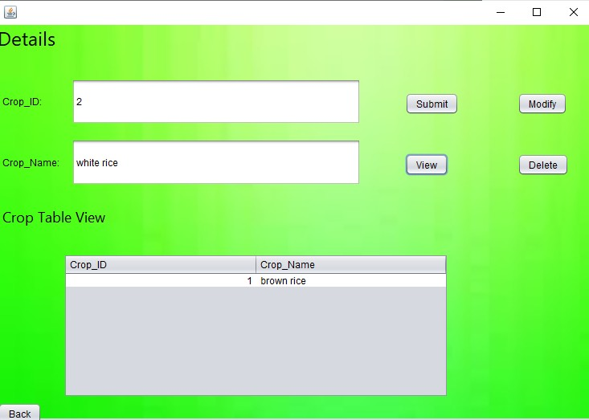

**Diseases:**

In the crop there will be two text fields one is crop_ID and other is Disease Name.Admin can click on the buttons to modify submit and delete the data. crop_ID should be integer and Disease name must be a string.

###### Insert option:‐

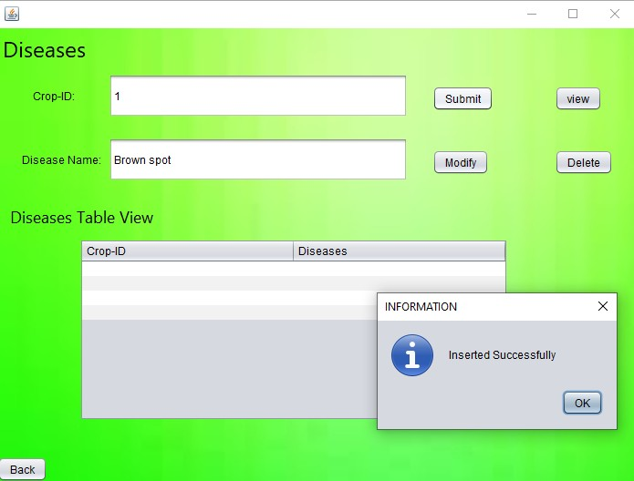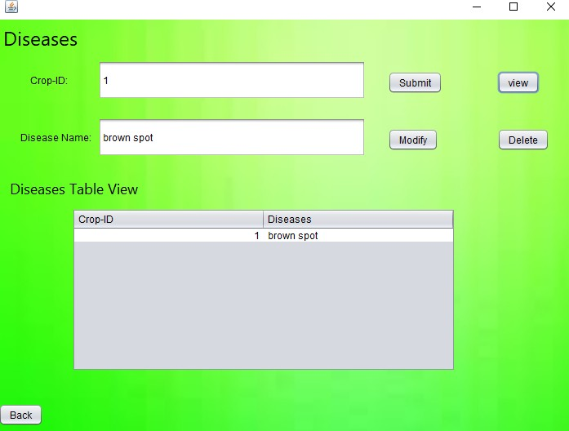

**Modify option:‐**

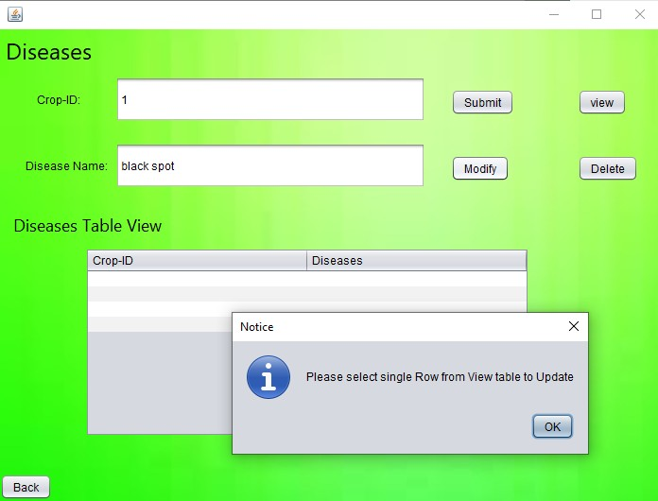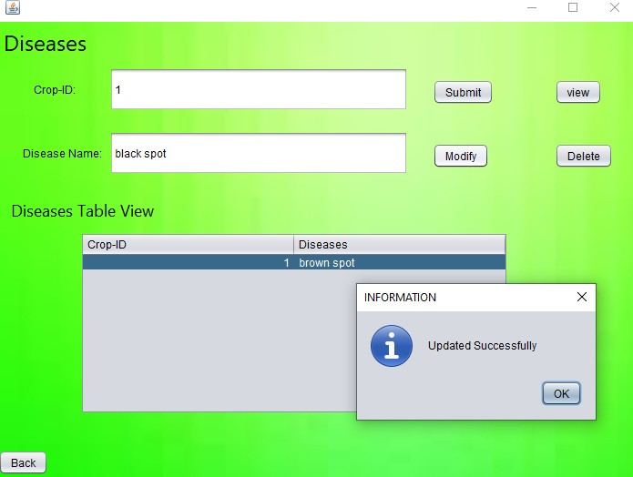

###### Delete option:‐

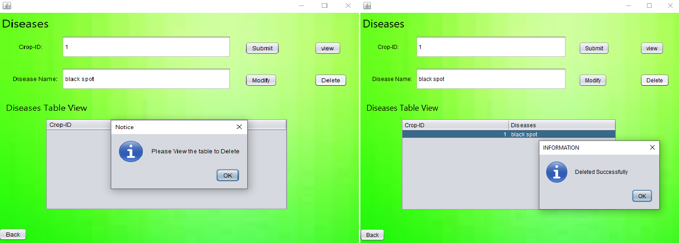

**View option:**

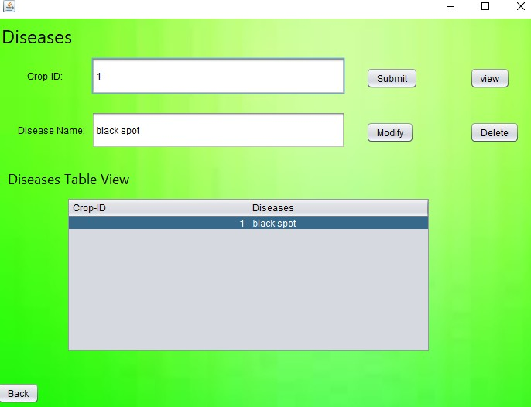

**Factors:**

In the crop there will be two text fields one is crop_ID and other is Factor Name.Admin can click on the buttons to modify submit and delete the data. crop_ID should be integer and Factor name must be a string.

###### Insert option:

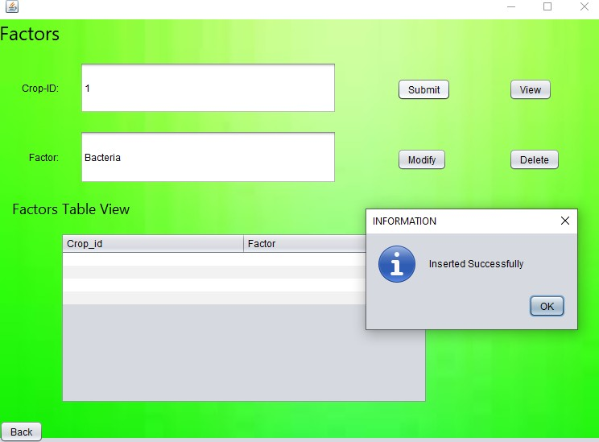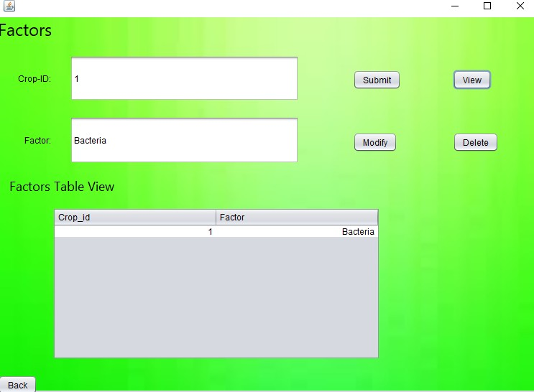

**Modify option:‐**

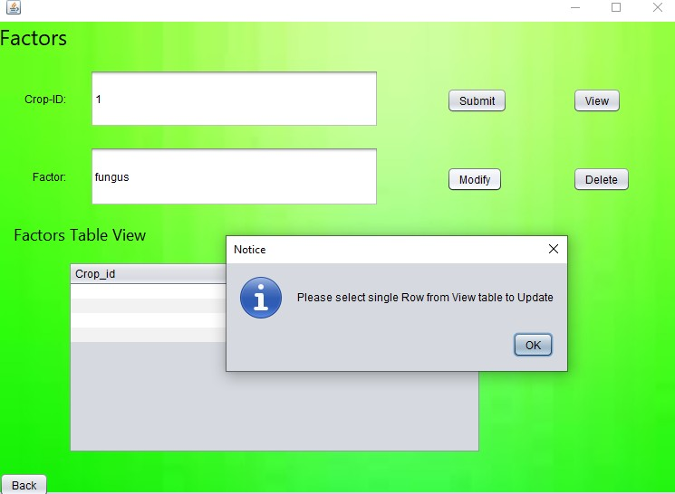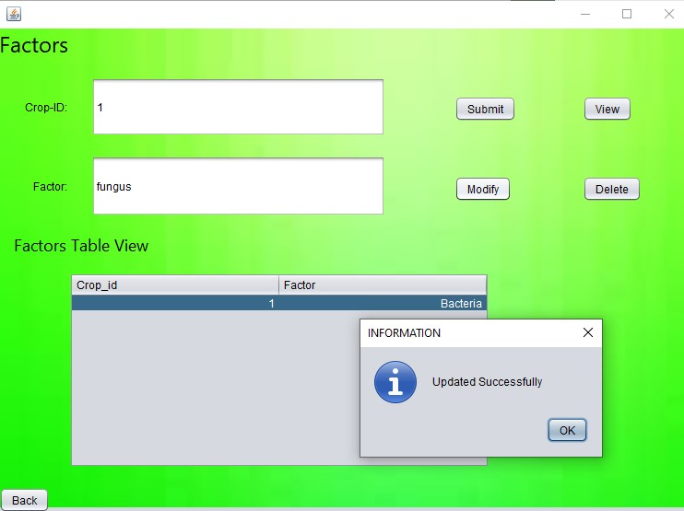

###### Delete:‐

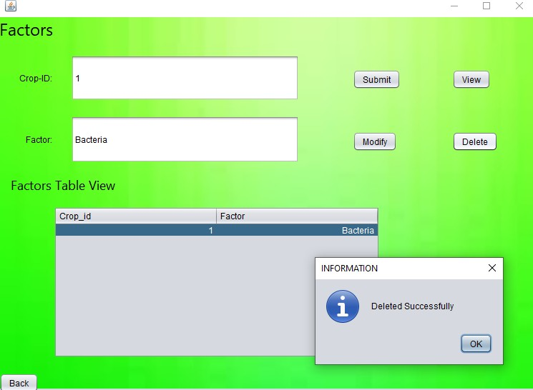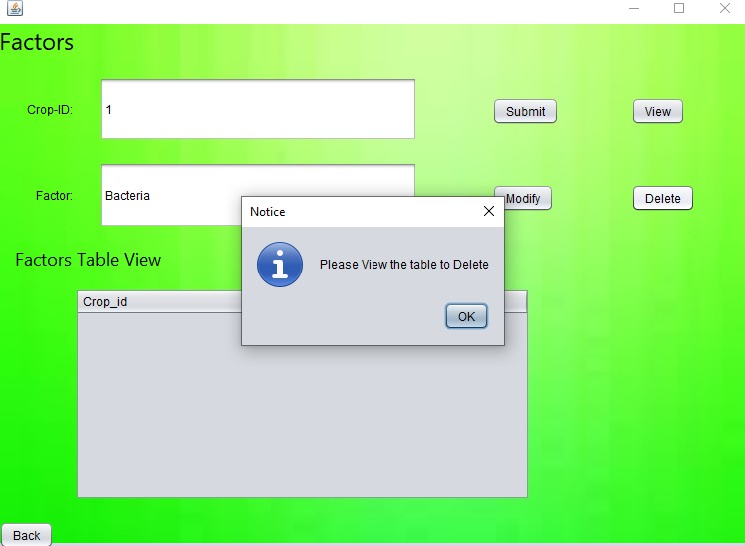

**View:‐**

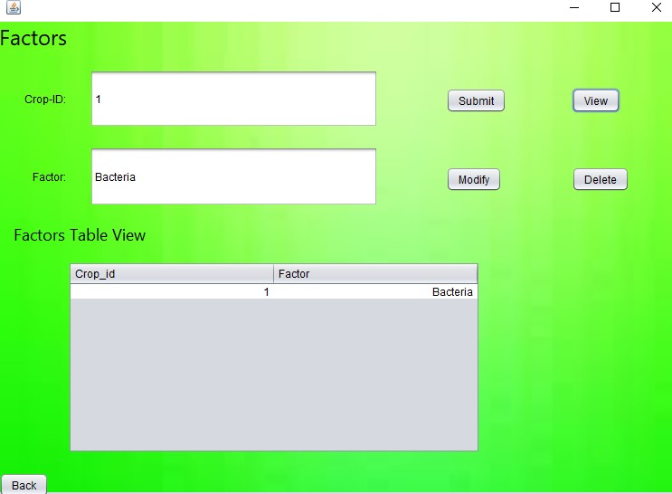

##### Symptoms:

In the crop there will be four text fields one is crop_ID ,High,low,medium. Admin can click on the buttons to modify submit and delete the data. crop_ID should be integer and High,low,medium must be a string.

###### Insert:

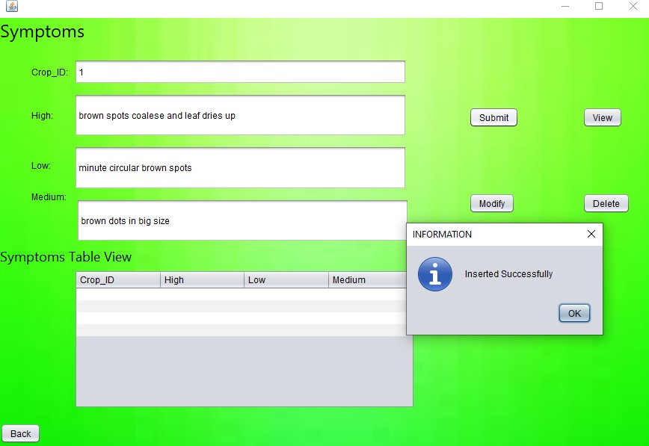

**Modify:**

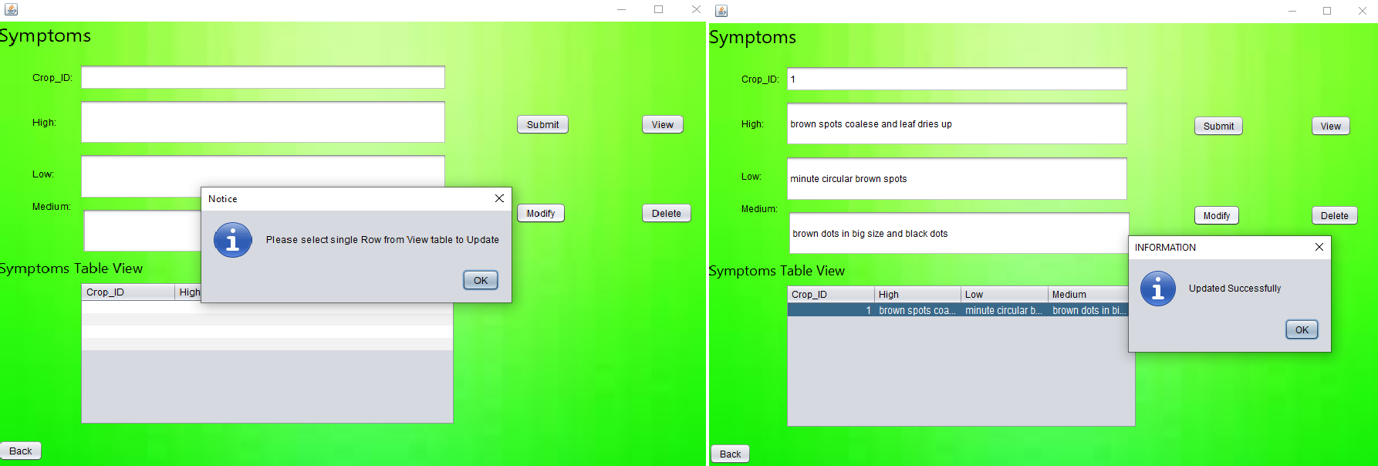

###### Delete:

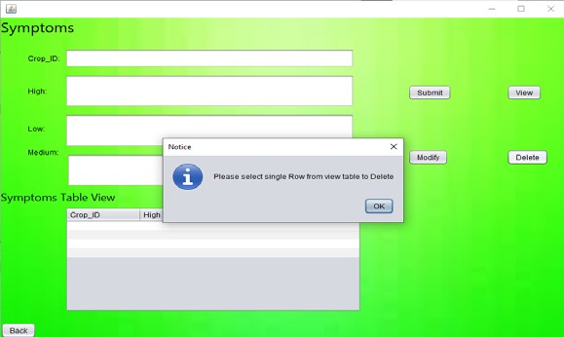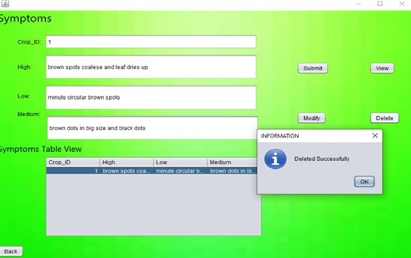

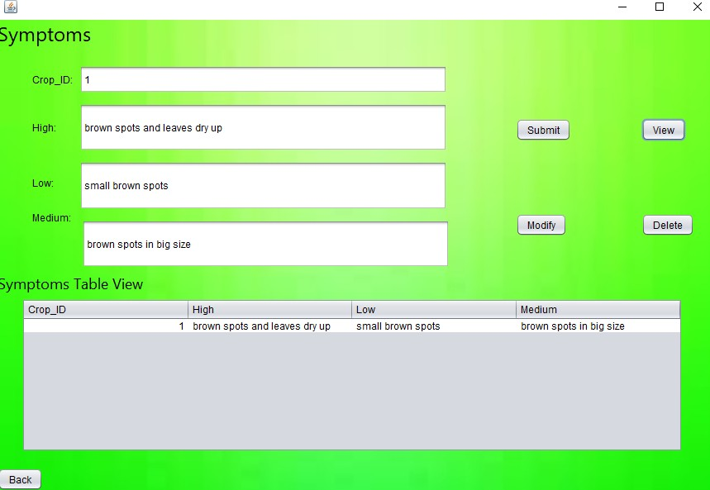

**Check severity:‐**

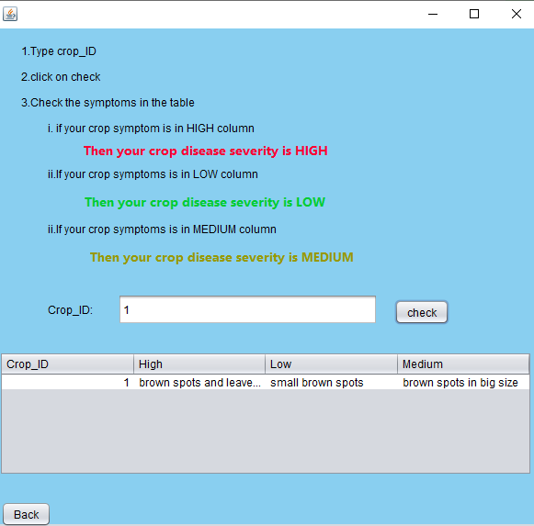

If user or admin click on back option the previous form will open and existing form will get disappeared.

**RESULTS**

I have successfully completed the mini-project ***“Crop Disease severity”*** .

## DISCUSSION AND FUTURE WORK

This project contains the basic interaction of applying for internships by students and hiring of interns by project managers. It has a very basic user interface. Future scope would be to make the UI more appealing by using graphics. One more feature would be to allow student- users to upload their resumes and official documents required so that the project managers can take a look while they hire them. We can also think of including a feedback system to allow the users to leave their valuable feedback after using this app. Making this feedback to be publicly viewable, would attract many more users to use this app.

## REFERENCES